Practical Pandas, Matplotlib and Seaborn Training
Data Cleaning, Data Manipulation and Data Visualization - A Complete Practical Course
Kajola Gbenga
Data Scientist & AI Engineer
Training Manual and Facilitator Guide
Companion files: retail_sales_raw.csv, retail_sales_training.xlsx, pandas_matplotlib_seaborn_training.ipynb

Table of Contents

How to Use This Manual
This manual is the printed companion to the Jupyter notebook pandas_matplotlib_seaborn_training.ipynb and the accompanying data files retail_sales_raw.csv and retail_sales_training.xlsx. Every code example in this manual is the exact code used in the notebook, and every chart shown is the real chart produced by running that code on the training dataset - nothing here is illustrative or simplified.
The manual is organised into six parts: (1) loading and first exploration of the data, (2) data cleaning, (3) data manipulation, (4) data visualization with Matplotlib, (5) data visualization with Seaborn, and (6) a closing mini dashboard and course summary. Each topic gives a line-by-line explanation of the code first, followed by the code itself, followed by its output or chart where relevant, so that a facilitator can teach directly from these pages.
Standard hyphens are used throughout this document; no long dashes appear anywhere in this manual.

Practical Pandas, Matplotlib and Seaborn Training

Data Cleaning, Data Manipulation and Data Visualization - A Complete Hands-On Course
Prepared by: Kajola Gbenga
Data Scientist & AI Engineer
---

About this notebook
This notebook is a complete, line-by-line practical course built around one deliberately messy
retail sales dataset (retail_sales_raw.csv, also available as retail_sales_training.xlsx).
Every technique is demonstrated on real data with real problems, not on a toy example, so that
each idea can be taught, explained and reproduced in a classroom.
The notebook is organised into four parts:
1. Loading and first exploration of the raw data.
2. Data cleaning - every common pandas cleaning operation, explained line by line.
3. Data manipulation - selecting, sorting, grouping, reshaping, merging, time series and more.
4. Data visualization - every major chart type in Matplotlib and every major chart type in
Seaborn, each with an explanation of when and why you would use it.
Read the markdown cell above each code cell first - it explains, line by line, what the code
below it does and why. Then run the code cell and study the output.

0. Setup - importing the libraries we need
Line by line:
- import pandas as pd loads the pandas library, the core tool for tabular data in Python, and gives it the short alias pd.
- import numpy as np loads NumPy, which pandas is built on top of, and which we use directly for numeric operations such as np.where and np.select.
- import matplotlib.pyplot as plt loads Matplotlib's plotting interface, aliased as plt.
- import seaborn as sns loads Seaborn, a statistical plotting library built on top of Matplotlib, aliased as sns.
- %matplotlib inline is a notebook "magic command" that tells Jupyter to render charts directly inside the notebook.
- pd.set_option(...) widens how many columns and rows pandas prints, so wide tables are not truncated while we teach.
- sns.set_theme(...) sets a consistent, readable visual style for every chart in the notebook.
- warnings.filterwarnings('ignore') silences noisy, non-critical warnings so the teaching output stays clean.
Code
import pandas as pd
import numpy as np
import matplotlib.pyplot as plt
import matplotlib.ticker as mticker
import seaborn as sns
import warnings

warnings.filterwarnings('ignore')

%matplotlib inline

pd.set_option('display.max_columns', 60)
pd.set_option('display.width', 160)
pd.set_option('display.max_rows', 100)

sns.set_theme(style='whitegrid', palette='deep')
plt.rcParams['figure.figsize'] = (10, 6)
plt.rcParams['axes.titlesize'] = 14
plt.rcParams['axes.titleweight'] = 'bold'

print('Libraries loaded. pandas:', pd.__version__, '| numpy:', np.__version__)

PART 1 - Loading the data and first exploration
We will load the raw CSV file. The same data also exists as an Excel workbook
(retail_sales_training.xlsx), and we will show how to read that format too.

1.1 Reading a CSV file
Line by line:
- pd.read_csv('retail_sales_raw.csv') reads a comma separated file from disk into a pandas DataFrame, pandas' main table object.
- We assign the result to df, the variable we will clean and analyse for the rest of the notebook.
Code
df = pd.read_csv('retail_sales_raw.csv')
df.head()

1.2 Reading an Excel file (alternative source)
Line by line:
- pd.read_excel(path, sheet_name='Raw Sales Data') reads one named sheet from an Excel workbook into a DataFrame.
- sheet_name=None (shown commented out) would instead return a dictionary of every sheet in the file, keyed by sheet name - useful when a workbook has several related tables, as ours does (lookup tables for merging, covered in Part 3).
Code
df_from_excel = pd.read_excel('retail_sales_training.xlsx', sheet_name='Raw Sales Data')
print(df_from_excel.shape)
df_from_excel.head(3)

# all_sheets = pd.read_excel('retail_sales_training.xlsx', sheet_name=None) # returns a dict of DataFrames

1.3 Basic shape and structure
Line by line:
- df.shape returns a tuple (rows, columns), the size of the table.
- df.columns lists every column name.
- df.index shows the row index (row labels).
- df.dtypes shows the data type pandas inferred for every column - this is the single most
important first check in any cleaning project, because a column that *should* be numeric but
was inferred as object (text) tells you immediately that it contains dirty values.
Code
print('Shape (rows, columns):', df.shape)
print()
print('Columns:', list(df.columns))
print()
print('Index:', df.index)

Code
df.dtypes

1.4 Looking at the data: head, tail, sample
Line by line:
- df.head(10) shows the first 10 rows.
- df.tail(5) shows the last 5 rows.
- df.sample(5, random_state=1) shows 5 *random* rows - important, because the first and last
rows of a file are often not representative of the messiness hiding in the middle.
Code
df.head(10)

Code
df.tail(5)

Code
df.sample(5, random_state=1)

1.5 Summary information: `info()` and `describe()`
Line by line:
- df.info() prints the row count, column count, non-null count per column, and dtype per
column in one compact report - the fastest way to see where missing data lives.
- df.describe() gives summary statistics (count, mean, std, min, quartiles, max) for numeric
columns only, by default.
- df.describe(include='object') gives the equivalent summary (count, unique, top, freq) for
text columns.
- df.describe(include='all') combines both, with NaN shown where a statistic does not apply.
Code
df.info()

Code
df.describe()

Code
df.describe(include='object')

1.6 Counting missing values and duplicates
Line by line:
- df.isna() returns a same-shaped DataFrame of True/False values, True where data is missing.
- .sum() on that adds the True values down each column, giving a missing-value count per column.
- df.isna().sum().sum() gives the grand total of missing cells in the whole table.
- df.duplicated() flags rows that are an exact repeat of an earlier row.
- df.duplicated().sum() counts how many exact duplicate rows exist.
Code
missing_counts = df.isna().sum().sort_values(ascending=False)
print(missing_counts)
print()
print('Total missing cells:', df.isna().sum().sum())
print('Exact duplicate rows:', df.duplicated().sum())

1.7 Unique values and value counts
Line by line:
- df['Country'].unique() lists every distinct value that appears in the Country column -
this is how we discover that "Nigeria", "nigeria", "NIGERIA" and " Nigeria" are all being
treated as different categories.
- df['Country'].nunique() counts how many distinct values there are.
- df['OrderStatus'].value_counts() counts how often each distinct value occurs, sorted from
most to least common - the classic first step for spotting inconsistent categorical data.
- value_counts(dropna=False) includes missing values in the count.
Code
print('Unique Country values:', df['Country'].dropna().unique())
print()
print('Number of unique Country values (should be far fewer after cleaning):', df['Country'].nunique())

Code
df['OrderStatus'].value_counts(dropna=False)

Code
df['PaymentMethod'].value_counts(dropna=False)

PART 2 - Data Cleaning
This is the heart of the course. We will work through every major category of data cleaning
in pandas, in the order a real project usually needs them:
2.1 Handling missing values
2.2 Removing duplicate rows
2.3 Fixing data types (numbers stored as text, dates stored as text)
2.4 Cleaning text columns (case, whitespace, inconsistent spelling)
2.5 Standardising categorical values with mapping dictionaries
2.6 Detecting and handling outliers and impossible values
2.7 Renaming and reordering columns
2.8 Final validation of the cleaned dataset
We will build a new, cleaned DataFrame called clean step by step, so df always stays
available as the original untouched raw data for comparison.

2.1 Handling missing values
Line by line:
- df.dropna() removes any row that has at least one missing value anywhere - useful only when
missingness is rare and rows are cheap to lose. We do not use this on the whole table here,
because it would throw away most of our rows.
- df.dropna(subset=['OrderID']) removes rows only where the named column(s) are missing - this
is safe to use on OrderID because a row with no order id is not usable at all.
- df.dropna(how='all') removes a row only if every column in it is missing - this is exactly
the right tool for removing the fully blank rows we saw in the data.
- df.fillna(value) fills missing values with a fixed value.
- df['Rating'].fillna(df['Rating'].median()) fills missing numeric values with the column
median - a common, robust choice because the median is not distorted by outliers.
- df['CustomerGender'].fillna('Unknown') fills a missing category with an explicit "Unknown"
label, which is usually better than deleting the row or guessing.
- df.fillna(method='ffill') (forward fill) copies the last valid value forward - most useful in
time-ordered data.
- df.interpolate() fills numeric gaps by estimating a value between the surrounding numbers.
Code
clean = df.copy()

# Step 1: drop rows that are completely blank (every column missing)
before = len(clean)
clean = clean.dropna(how='all')
print(f'Removed {before - len(clean)} fully blank rows. Remaining rows: {len(clean)}')

# Step 2: an OrderID is mandatory - a row without one cannot be reconciled with any sale
before = len(clean)
clean = clean.dropna(subset=['OrderID'])
print(f'Removed {before - len(clean)} rows with a missing OrderID. Remaining rows: {len(clean)}')

Code
# Demonstrating fillna in three different, common styles

# (a) fill a categorical column with an explicit label
demo_gender = df['CustomerGender'].fillna('Unknown')
print(demo_gender.value_counts(dropna=False))

Code
# (b) fill a numeric column with the median (robust to outliers)
demo_rating = df['Rating'].fillna(df['Rating'].median())
print('Missing before:', df['Rating'].isna().sum(), '| Missing after fillna:', demo_rating.isna().sum())

Code
# (c) forward fill and interpolate, shown on a small numeric example so the mechanics are visible
example = pd.Series([10, np.nan, np.nan, 40, np.nan, 60])
print('Original: ', example.tolist())
print('Forward fill: ', example.ffill().tolist())
print('Backward fill: ', example.bfill().tolist())
print('Interpolated: ', example.interpolate().tolist())

2.2 Removing duplicate rows
Line by line:
- clean.duplicated() flags exact duplicate rows (every column identical).
- clean.drop_duplicates() removes exact duplicate rows, keeping the first occurrence by default.
- clean.drop_duplicates(subset=['OrderID'], keep='first') removes rows that share the same
OrderID, even if other columns differ slightly (our "near duplicate, re-keyed" rows) - this
is the more realistic real-world rule, because the business key is the order id, not the whole row.
- keep='last' keeps the most recent duplicate instead of the first; keep=False drops every
copy of a duplicated row, keeping none of them.
Code
print('Exact duplicate rows before removal:', clean.duplicated().sum())
clean = clean.drop_duplicates()
print('Exact duplicate rows after removal:', clean.duplicated().sum())

print()
print('Rows sharing an OrderID before removal:', clean.duplicated(subset=['OrderID']).sum())
clean = clean.drop_duplicates(subset=['OrderID'], keep='first')
print('Rows remaining:', len(clean))

2.3 Fixing data types
Several columns look numeric or date-like but were loaded as plain text (object), because a
few dirty values in each column stopped pandas from inferring the correct type automatically.
Line by line:
- clean['UnitPrice'].str.replace('$', '', regex=False) removes the currency symbol.
- .str.replace(',', '', regex=False) removes thousands separators.
- pd.to_numeric(series, errors='coerce') converts text to numbers, turning anything that still
cannot be parsed (like the "N/A" values) into NaN instead of raising an error - this is the
safest way to convert a dirty numeric column.
- pd.to_datetime(series, errors='coerce', dayfirst=False) parses many different date string
formats into real datetime64 values in one call; unparseable strings become NaT (Not a Time),
the datetime equivalent of NaN.
- clean['Quantity'].astype('Int64') casts to pandas' nullable integer type (capital I), which,
unlike NumPy's int64, is allowed to hold missing values.
Code
# Clean the price column: strip currency symbols and commas, then convert to numeric
clean['UnitPrice'] = (
clean['UnitPrice']
.astype(str)
.str.replace('$', '', regex=False)
.str.replace(',', '', regex=False)
.str.strip()
)
clean['UnitPrice'] = pd.to_numeric(clean['UnitPrice'], errors='coerce')
print(clean['UnitPrice'].describe())

Code
# Parse the OrderDate column, which mixes five different date string formats, into real dates
clean['OrderDate'] = pd.to_datetime(clean['OrderDate'], errors='coerce', format='mixed', dayfirst=False)
print(clean['OrderDate'].dtype)
print('Unparseable / missing dates after conversion:', clean['OrderDate'].isna().sum())
clean['OrderDate'].head()

Code
# Convert Quantity and CustomerAge to pandas nullable integer types so NaN can co-exist with whole numbers
clean['Quantity'] = pd.to_numeric(clean['Quantity'], errors='coerce').astype('Int64')
clean['CustomerAge'] = pd.to_numeric(clean['CustomerAge'], errors='coerce').astype('Int64')
clean['Rating'] = pd.to_numeric(clean['Rating'], errors='coerce').astype('Int64')
clean.dtypes

2.4 Cleaning text columns
Line by line:
- .str.strip() removes leading and trailing whitespace (" Nigeria" and "Nigeria " both become "Nigeria").
- .str.lower() / .str.upper() / .str.title() normalise letter case.
- .str.replace(pattern, repl, regex=True) performs a find-and-replace, optionally using a regular expression.
- .str.contains('pattern') returns True/False for whether each value contains a substring or pattern - useful for flagging malformed values, such as the malformed emails in this data.
- .str.extract(r'(pattern)') pulls a substring out of each value using a regex capture group.
- .str.split(',').str[0] splits a string on a separator and keeps one piece - used below to fix names stored as "Lastname, Firstname".
Code
# Standardise CustomerName: strip whitespace, fix 'Lastname, Firstname' pattern, then Title Case
def normalise_name(name):
if pd.isna(name):
return name
name = str(name).strip()
if ',' in name:
last, first = [p.strip() for p in name.split(',', 1)]
name = f'{first} {last}'
return name.title()

clean['CustomerName'] = clean['CustomerName'].apply(normalise_name)
clean['CustomerName'].head(10)

Code
# Flag malformed emails using str.contains with a simple regex, before deciding how to handle them
valid_email_pattern = r'^[\w\.-]+@[\w\.-]+\.\w+$'
is_valid_email = clean['CustomerEmail'].str.contains(valid_email_pattern, regex=True, na=False)
print('Valid-looking emails:', is_valid_email.sum())
print('Missing or malformed emails:', (~is_valid_email).sum())

# Malformed (non-null but not matching the pattern) emails are set to missing, to be handled like any other NaN
clean.loc[(~is_valid_email) & clean['CustomerEmail'].notna(), 'CustomerEmail'] = np.nan

Code
# Clean PaymentMethod and OrderStatus: strip whitespace and standardise casing to Title Case
for col in ['PaymentMethod', 'OrderStatus']:
clean[col] = clean[col].astype(str).str.strip().str.title()
clean.loc[clean[col] == 'Nan', col] = np.nan

print(clean['PaymentMethod'].value_counts(dropna=False))
print()
print(clean['OrderStatus'].value_counts(dropna=False))

2.5 Standardising categorical values with a mapping dictionary
Title-casing fixed *some* inconsistency, but country names need a proper lookup dictionary,
because "USA", "U.S.A" and "US" do not share a common pattern that .str.title() can fix.
Line by line:
- We first strip and title-case the raw values to shrink the number of distinct spellings.
- country_map is a Python dictionary from every messy variant we still see to one clean, canonical name.
- clean['Country'].map(country_map) looks each value up in the dictionary and returns the clean
version; any value not found in the dictionary becomes NaN (a useful side effect that
doubles as a validation check).
- np.where(condition, value_if_true, value_if_false) is shown as an alternative for a simple
two-way recoding.
Code
clean['Country'] = clean['Country'].astype(str).str.strip().str.title()
clean.loc[clean['Country'] == 'Nan', 'Country'] = np.nan

print('Distinct values before dictionary mapping:')
print(sorted(clean['Country'].dropna().unique()))

Code
country_map = {
'Nigeria': 'Nigeria',
'United States': 'United States', 'Usa': 'United States', 'U.S.A': 'United States', 'Us': 'United States',
'United Kingdom': 'United Kingdom', 'Uk': 'United Kingdom', 'U.K.': 'United Kingdom',
'England': 'United Kingdom', 'Britain': 'United Kingdom',
'Germany': 'Germany', 'Deutschland': 'Germany',
'Canada': 'Canada',
'South Africa': 'South Africa', 'S. Africa': 'South Africa',
'Kenya': 'Kenya',
'Ghana': 'Ghana',
'India': 'India',
'France': 'France',
'Brazil': 'Brazil',
'Uae': 'UAE', 'U.A.E': 'UAE', 'United Arab Emirates': 'UAE',
}

clean['Country'] = clean['Country'].map(country_map)
print('Distinct values after dictionary mapping:')
print(sorted(clean['Country'].dropna().unique()))
print()
print('Rows where Country could not be matched to the dictionary (now NaN):', clean['Country'].isna().sum())

Code
# np.where as a quick alternative for simple two-way recoding, demonstrated on CustomerGender
clean['CustomerGender'] = clean['CustomerGender'].astype(str).str.strip().str.upper().str[0]
clean.loc[~clean['CustomerGender'].isin(['M', 'F']), 'CustomerGender'] = np.nan
clean['CustomerGender'] = np.where(clean['CustomerGender'] == 'M', 'Male',
np.where(clean['CustomerGender'] == 'F', 'Female', 'Unknown'))
clean.loc[clean['CustomerGender'] == 'Unknown', 'CustomerGender'] = np.nan
clean['CustomerGender'].value_counts(dropna=False)

2.6 Detecting and handling outliers and impossible values
Line by line:
- The IQR (interquartile range) method: compute the 25th percentile (Q1) and 75th
percentile (Q3), then flag anything below Q1 - 1.5*IQR or above Q3 + 1.5*IQR as a
statistical outlier.
- The domain-knowledge method: some values are impossible regardless of statistics - a
negative age, an age above roughly 110, a discount above 1 (100 percent), or a rating outside
1 to 5. These are cleaned using direct boolean conditions, not statistics.
- .clip(lower, upper) caps values at a floor and/or ceiling instead of removing them.
Code
# Domain-knowledge cleaning: values that are impossible no matter their statistical distribution
before_invalid_age = ((clean['CustomerAge'] < 0) | (clean['CustomerAge'] > 110)).sum()
clean.loc[(clean['CustomerAge'] < 0) | (clean['CustomerAge'] > 110), 'CustomerAge'] = pd.NA
print('Impossible ages set to missing:', before_invalid_age)

before_invalid_qty = ((clean['Quantity'] <= 0)).sum()
clean.loc[clean['Quantity'] <= 0, 'Quantity'] = pd.NA
print('Zero or negative quantities set to missing:', before_invalid_qty)

before_invalid_discount = (clean['Discount'] > 1).sum()
clean.loc[clean['Discount'] > 1, 'Discount'] = np.nan
print('Discounts above 100 percent set to missing:', before_invalid_discount)

before_invalid_rating = (~clean['Rating'].between(1, 5) & clean['Rating'].notna()).sum()
clean.loc[~clean['Rating'].between(1, 5), 'Rating'] = pd.NA
print('Ratings outside 1 to 5 set to missing:', before_invalid_rating)

Code
# Statistical outlier detection with the IQR method, applied to UnitPrice
Q1 = clean['UnitPrice'].quantile(0.25)
Q3 = clean['UnitPrice'].quantile(0.75)
IQR = Q3 - Q1
lower_bound = Q1 - 1.5 * IQR
upper_bound = Q3 + 1.5 * IQR

outliers = clean[(clean['UnitPrice'] < lower_bound) | (clean['UnitPrice'] > upper_bound)]
print(f'IQR bounds: [{lower_bound:.2f}, {upper_bound:.2f}]')
print(f'Number of statistical price outliers: {len(outliers)}')

# Rather than deleting them (they are legitimate premium electronics, not errors), we cap (clip) them
clean['UnitPrice'] = clean['UnitPrice'].clip(lower=0, upper=upper_bound)

2.7 Renaming and reordering columns
Line by line:
- clean.rename(columns={...}) renames specific columns using a dictionary of old name to new name.
- clean.columns = [...] replaces every column name at once - fast, but you must supply a full list in the correct order.
- clean[new_order] reindexes the columns into a chosen order by passing a list of column names.
Code
clean = clean.rename(columns={
'CustomerAge': 'Age',
'CustomerGender': 'Gender',
'CustomerEmail': 'Email',
'CustomerName': 'Name',
})

new_order = ['OrderID', 'OrderDate', 'Name', 'Email', 'Gender', 'Age', 'Country',
'ProductCategory', 'ProductName', 'Quantity', 'UnitPrice', 'Discount',
'ShippingCost', 'PaymentMethod', 'OrderStatus', 'Rating', 'SalesRep', 'Notes']
clean = clean[new_order]
clean.head()

2.8 Adding a derived column and final validation of the cleaned dataset
Line by line:
- We create NetSales, a new numeric column computed from other columns - Quantity * UnitPrice * (1 - Discount).
Rows where Discount is missing use .fillna(0) first, since no discount recorded most often
means no discount was applied.
- clean.isna().sum() gives a final missing-value report on the cleaned data, for comparison with Part 1.
- clean.duplicated().sum() confirms no duplicate rows remain.
- clean.reset_index(drop=True) rebuilds the row index as a clean 0..n-1 sequence after all the
dropping and filtering above (row numbers were left with gaps).
Code
clean['NetSales'] = (
clean['Quantity'].astype('Float64')
* clean['UnitPrice']
* (1 - clean['Discount'].fillna(0))
)

clean = clean.reset_index(drop=True)

print('Final cleaned shape:', clean.shape)
print()
print('Missing values remaining per column:')
print(clean.isna().sum())
print()
print('Duplicate rows remaining:', clean.duplicated().sum())

Code
clean.head(10)

Code
clean.to_csv('retail_sales_clean.csv', index=False)
print('Cleaned dataset saved to retail_sales_clean.csv')

PART 3 - Data Manipulation
With a clean dataset in hand, this part covers the pandas operations used every day to answer
business questions: selecting and filtering, sorting, creating columns, grouping and
aggregating, pivoting and reshaping, merging with other tables, binning, ranking, time series
operations and multi-index operations.
We load the lookup tables we will need for merging in this part as well.
Code
country_region = pd.read_csv('country_region_lookup.csv')
category_target = pd.read_csv('category_target_lookup.csv')
sales_rep_lookup = pd.read_csv('sales_rep_lookup.csv')

country_region

3.1 Selecting and filtering
Line by line:
- clean['Country'] selects a single column as a Series.
- clean[['Country', 'NetSales']] selects several columns as a DataFrame (note the double brackets).
- clean.loc[row_condition, column_list] selects by label - rows matching a boolean condition, and specific columns.
- clean.iloc[0:5, 0:3] selects by position - the first 5 rows and first 3 columns, regardless of labels.
- Boolean indexing: clean[clean['Country'] == 'Nigeria'] keeps only rows where the condition is True.
- .isin([...]) keeps rows whose value is in a given list.
- .between(a, b) keeps rows whose numeric value falls in a range (inclusive by default).
- .query('expression') filters using a readable string expression, useful for combining several conditions.
Code
nigeria_sales = clean.loc[clean['Country'] == 'Nigeria', ['OrderID', 'ProductName', 'NetSales']]
print(nigeria_sales.shape)
nigeria_sales.head()

Code
clean.iloc[0:5, 0:4]

Code
top_categories = clean[clean['ProductCategory'].isin(['Electronics', 'Furniture'])]
print(top_categories.shape)

mid_age = clean[clean['Age'].between(25, 40)]
print(mid_age.shape)

Code
high_value_delivered = clean.query("OrderStatus == 'Delivered' and NetSales > 500")
print(high_value_delivered.shape)
high_value_delivered.head()

3.2 Sorting
Line by line:
- clean.sort_values('NetSales', ascending=False) sorts rows by one column, largest first.
- clean.sort_values(['Country', 'NetSales'], ascending=[True, False]) sorts by several columns
at once, with an independent direction for each.
- clean.nlargest(5, 'NetSales') is a fast shortcut for "top 5 rows by this column", equivalent
to sorting and taking the head, but clearer to read.
- clean.nsmallest(5, 'NetSales') is the same idea for the smallest values.
Code
clean.sort_values('NetSales', ascending=False).head(10)[['OrderID', 'Country', 'ProductName', 'NetSales']]

Code
clean.nlargest(5, 'NetSales')[['OrderID', 'ProductName', 'NetSales']]

3.3 Creating new columns
Line by line:
- Direct arithmetic on columns (vectorised) is always the fastest way to create a new column,
as shown already with NetSales.
- .apply(function, axis=1) runs a Python function once per row, useful when the logic is
too complex for simple arithmetic; slower than vectorised code, so used only when needed.
- lambda is a small, unnamed inline function, often paired with .apply() or .map().
- np.select(conditions, choices, default) evaluates several conditions in order and assigns the
matching choice - the vectorised, fast equivalent of a chain of if/elif/else.
Code
clean['OrderYear'] = clean['OrderDate'].dt.year
clean['OrderMonth'] = clean['OrderDate'].dt.month_name()
clean['OrderWeekday'] = clean['OrderDate'].dt.day_name()

clean[['OrderDate', 'OrderYear', 'OrderMonth', 'OrderWeekday']].head()

Code
# apply + lambda: build a simple 'HighValue' flag row by row
clean['HighValue'] = clean.apply(
lambda row: 'Yes' if pd.notna(row['NetSales']) and row['NetSales'] > 500 else 'No', axis=1
)
clean['HighValue'].value_counts()

Code
# np.select: assign an age band using several ordered conditions at once (vectorised, fast)
age_float = clean['Age'].astype('Float64')
conditions = [
(age_float < 25).fillna(False),
(age_float.between(25, 34)).fillna(False),
(age_float.between(35, 49)).fillna(False),
(age_float >= 50).fillna(False),
]
choices = ['Under 25', '25 to 34', '35 to 49', '50 and above']
clean['AgeBand'] = np.select(conditions, choices, default='Unknown')
clean['AgeBand'].value_counts()

3.4 GroupBy and aggregation
Line by line:
- clean.groupby('ProductCategory')['NetSales'].sum() splits the data into groups by category,
then sums NetSales within each group - the classic split-apply-combine pattern.
- .groupby([...]) can group by more than one column at once, producing a hierarchical result.
- .agg({...}) applies a different aggregation to each column in the same call.
- Named aggregation (pd.NamedAgg) lets you compute several statistics on the same column and
give each resulting column a clear, chosen name, avoiding awkward multi-level column headers.
- .reset_index() turns the grouped index back into ordinary columns, which is usually easier
to read and to plot.
Code
category_sales = clean.groupby('ProductCategory')['NetSales'].sum().sort_values(ascending=False)
category_sales

Code
country_category_sales = clean.groupby(['Country', 'ProductCategory'])['NetSales'].sum()
country_category_sales.head(10)

Code
summary = clean.groupby('ProductCategory').agg(
TotalSales=pd.NamedAgg(column='NetSales', aggfunc='sum'),
AverageSales=pd.NamedAgg(column='NetSales', aggfunc='mean'),
OrderCount=pd.NamedAgg(column='OrderID', aggfunc='count'),
AverageRating=pd.NamedAgg(column='Rating', aggfunc='mean'),
).reset_index().sort_values('TotalSales', ascending=False)

summary

3.5 Pivot tables and cross tabulation
Line by line:
- pd.pivot_table(data, values, index, columns, aggfunc) reshapes long data into a wide summary
grid - rows become index, one distinct value per columns becomes its own column, and cells
hold the aggregated values.
- pd.crosstab(row_series, col_series) is a specialised pivot table that simply counts how
often each combination of two categorical variables occurs - the fastest way to build a
frequency table between two categories.
- margins=True adds row and column totals to either function.
Code
pivot_sales = pd.pivot_table(
clean, values='NetSales', index='ProductCategory', columns='OrderYear',
aggfunc='sum', fill_value=0, margins=True, margins_name='Total'
)
pivot_sales

Code
status_by_category = pd.crosstab(clean['ProductCategory'], clean['OrderStatus'], margins=True)
status_by_category

3.6 Reshaping data: melt, pivot, stack and unstack
Line by line:
- pd.melt(wide_df, id_vars=[...], value_vars=[...]) converts wide data (one column per
category) into long / tidy data (one row per category), the format most plotting and
modelling functions expect.
- .pivot(index=, columns=, values=) is the inverse of melt - it turns long data back into wide data (it does not aggregate; the index/columns combination must already be unique).
- .stack() moves the innermost column level into the row index, making the table taller and narrower.
- .unstack() is the inverse - it moves a row index level out into columns, making the table wider.
Code
wide = pivot_sales.drop(columns='Total').drop(index='Total').reset_index()
wide.columns = wide.columns.astype(str)
wide

Code
long = pd.melt(wide, id_vars='ProductCategory', var_name='OrderYear', value_name='NetSales')
long.head(10)

Code
back_to_wide = long.pivot(index='ProductCategory', columns='OrderYear', values='NetSales')
back_to_wide

Code
stacked = back_to_wide.stack()
print(stacked.head(6))
print()
unstacked = stacked.unstack()
unstacked.head()

3.7 Merging, joining and concatenating
Line by line:
- pd.merge(left, right, on='key', how='left') combines two tables on a shared key column, the
same idea as a SQL join. how controls which rows survive:
- 'inner' keeps only keys present in both tables.
- 'left' keeps every row of the left table, filling with NaN where the right table has no match.
- 'right' keeps every row of the right table.
- 'outer' keeps every key from either table.
- left.join(right) is a convenience method for merging on the index instead of a column.
- pd.concat([df1, df2]) stacks tables - axis=0 (default) stacks rows on top of each other;
axis=1 places tables side by side, aligning on the index.
Code
merged = clean.merge(country_region, on='Country', how='left')
merged = merged.merge(category_target, on='ProductCategory', how='left')
merged = merged.merge(sales_rep_lookup, on='SalesRep', how='left')

print(merged.shape)
merged[['OrderID', 'Country', 'Region', 'CurrencyCode', 'ProductCategory',
'CategoryManager', 'SalesRep', 'Team']].head()

Code
# inner vs left vs outer, demonstrated on two small example tables
left_tbl = pd.DataFrame({'key': ['A', 'B', 'C'], 'left_val': [1, 2, 3]})
right_tbl = pd.DataFrame({'key': ['B', 'C', 'D'], 'right_val': [20, 30, 40]})

print('inner join:')
print(pd.merge(left_tbl, right_tbl, on='key', how='inner'))
print()
print('left join:')
print(pd.merge(left_tbl, right_tbl, on='key', how='left'))
print()
print('outer join:')
print(pd.merge(left_tbl, right_tbl, on='key', how='outer'))

Code
# concat: stacking two slices of the same table back together (axis=0, the default)
first_half = clean.iloc[:5]
second_half = clean.iloc[5:10]
stacked_rows = pd.concat([first_half, second_half], axis=0)
print(stacked_rows.shape)

3.8 Binning numeric data with cut and qcut
Line by line:
- pd.cut(series, bins=[...], labels=[...]) groups numeric values into bins with **boundaries
you choose** - equal-width or custom-width ranges.
- pd.qcut(series, q=4, labels=[...]) groups numeric values into bins that each contain roughly
the same number of rows (quantiles) - useful for building balanced segments such as
spending quartiles.
Code
clean['SalesBand'] = pd.cut(
clean['NetSales'], bins=[0, 100, 300, 700, np.inf],
labels=['Small (0-100)', 'Medium (100-300)', 'Large (300-700)', 'Very Large (700+)']
)
clean['SalesBand'].value_counts().sort_index()

Code
clean['SpendQuartile'] = pd.qcut(clean['NetSales'].rank(method='first'), q=4,
labels=['Q1 - Lowest', 'Q2', 'Q3', 'Q4 - Highest'])
clean['SpendQuartile'].value_counts().sort_index()

3.9 Ranking and cumulative statistics
Line by line:
- .rank(ascending=False) assigns a rank to each value, largest = rank 1.
- .cumsum() running total; .cumprod() running product; .cummax() / .cummin() running max / min.
- .diff() difference from the previous row; .pct_change() percentage change from the previous row -
both are especially useful once data is sorted by date, for measuring period-over-period change.
Code
category_rank = clean.groupby('ProductCategory')['NetSales'].sum().rank(ascending=False)
category_rank.sort_values()

Code
monthly = clean.dropna(subset=['OrderDate']).set_index('OrderDate').sort_index()['NetSales'].resample('MS').sum()
monthly_df = monthly.to_frame('MonthlySales')
monthly_df['CumulativeSales'] = monthly_df['MonthlySales'].cumsum()
monthly_df['MonthOverMonthChangePct'] = monthly_df['MonthlySales'].pct_change() * 100
monthly_df.head(8)

3.10 Time series operations
Line by line:
- .dt.year, .dt.month, .dt.day_name(), .dt.quarter (the .dt accessor) pull date parts out of a datetime column.
- .set_index('OrderDate') makes the date column the row index, which is required for
time-series-specific tools such as resampling.
- .resample('MS').sum() groups a datetime-indexed series into calendar buckets ('MS' = month
start, 'W' = week, 'Q' = quarter, 'Y' = year) and aggregates each bucket - conceptually a
groupby specialised for time.
- .rolling(window=3).mean() computes a moving average over a trailing window of periods,
smoothing out short-term noise to reveal the underlying trend.
Code
ts = clean.dropna(subset=['OrderDate']).set_index('OrderDate').sort_index()

daily_sales = ts['NetSales'].resample('D').sum()
monthly_sales = ts['NetSales'].resample('MS').sum()
quarterly_sales = ts['NetSales'].resample('QE').sum()

print('Daily series length:', len(daily_sales))
print('Monthly series length:', len(monthly_sales))
print('Quarterly series length:', len(quarterly_sales))

monthly_sales.head()

Code
rolling_avg = monthly_sales.rolling(window=3).mean()
pd.DataFrame({'MonthlySales': monthly_sales, 'ThreeMonthRollingAvg': rolling_avg}).head(8)

3.11 MultiIndex (hierarchical index) basics
Line by line:
- Grouping by more than one column produces a MultiIndex - an index with more than one level.
- .loc['Nigeria'] on a MultiIndex selects every row belonging to that outer level.
- .loc[('Nigeria', 'Electronics')] selects one specific combination of outer and inner level.
- .swaplevel() exchanges which level is outer and which is inner.
Code
multi = clean.groupby(['Country', 'ProductCategory'])['NetSales'].sum()
print(multi.index[:5])
print()
print(multi.loc['Nigeria'])

Code
print(multi.loc[('Nigeria', 'Electronics')])
print()
multi.swaplevel().sort_index().head()

3.12 Applying functions: apply, map and applymap
Line by line:
- Series.map(dict_or_function) transforms every value in a single column, one value at a time - we already used this for Country.
- DataFrame.apply(function, axis=1) runs a function once per row (or axis=0, once per column).
- DataFrame.map(function) (formerly applymap) runs a function on every individual cell in
a DataFrame - shown below formatting every numeric column for display.
- Vectorised operations are preferred over `apply` whenever possible - they run in optimised
C code rather than a slow Python loop over rows. apply is a fallback for logic that truly
cannot be expressed with vectorised pandas or NumPy operations.
Code
numeric_preview = clean[['UnitPrice', 'NetSales']].head()
formatted = numeric_preview.map(lambda x: f'{x:,.2f}' if pd.notna(x) else x)
formatted

3.13 Exporting the manipulated dataset
Line by line:
- merged.to_csv(path, index=False) writes the enriched table (after merging in the lookup
tables) back out to CSV, without writing the row index as a column.
- monthly_sales.to_frame().to_excel(path) writes a time series summary out to Excel for
sharing with non-technical stakeholders.
Code
merged.to_csv('retail_sales_merged.csv', index=False)
monthly_sales.to_frame('MonthlySales').to_excel('monthly_sales_summary.xlsx')
print('Exports complete: retail_sales_merged.csv, monthly_sales_summary.xlsx')

PART 4 - Data Visualization with Matplotlib
Matplotlib is the foundational plotting library in Python - Seaborn (Part 5) is built on top of
it. This part works through every major Matplotlib chart type, using the cleaned and merged
retail sales data. Each chart is shown with the full code needed to build it, labelled and
titled the way a chart intended for a report or a dashboard should be.
We first prepare a few small, reusable summary tables that most of the charts below will plot.
Code
plot_df = merged.dropna(subset=['NetSales', 'OrderDate']).copy()

# Convert pandas nullable dtypes (Int64 / Float64) to plain NumPy dtypes for chart compatibility
for col in ['Age', 'Quantity', 'Rating']:
plot_df[col] = plot_df[col].astype('float64')
plot_df['NetSales'] = plot_df['NetSales'].astype('float64')

cat_sales = plot_df.groupby('ProductCategory')['NetSales'].sum().sort_values(ascending=False)
monthly_sales_plot = plot_df.set_index('OrderDate').sort_index()['NetSales'].resample('MS').sum()
region_sales = plot_df.groupby('Region')['NetSales'].sum().sort_values(ascending=False)
status_counts = plot_df['OrderStatus'].value_counts()
country_year = plot_df.groupby(['Country', 'OrderYear'])['NetSales'].sum().unstack(fill_value=0)

cat_sales

4.1 Line chart
Line by line:
- fig, ax = plt.subplots(figsize=(...)) creates a figure (the whole canvas) and an axes object
(the individual chart) - the recommended, explicit way to build a Matplotlib chart.
- ax.plot(x, y, marker='o', ...) draws a line connecting the data points, with a circular marker at each point.
- ax.set_title / set_xlabel / set_ylabel label the chart.
- ax.xaxis.set_major_formatter and plt.xticks(rotation=...) keep date labels readable.
- fig.tight_layout() removes wasted whitespace so labels are not cut off.
Code
fig, ax = plt.subplots(figsize=(11, 5))
ax.plot(monthly_sales_plot.index, monthly_sales_plot.values, marker='o', color='#1F4E78', linewidth=2)
ax.set_title('Monthly Net Sales Over Time (Matplotlib Line Chart)')
ax.set_xlabel('Month')
ax.set_ylabel('Net Sales (USD)')
ax.yaxis.set_major_formatter(mticker.FuncFormatter(lambda x, _: f'{x:,.0f}'))
plt.xticks(rotation=45)
fig.tight_layout()
plt.show()

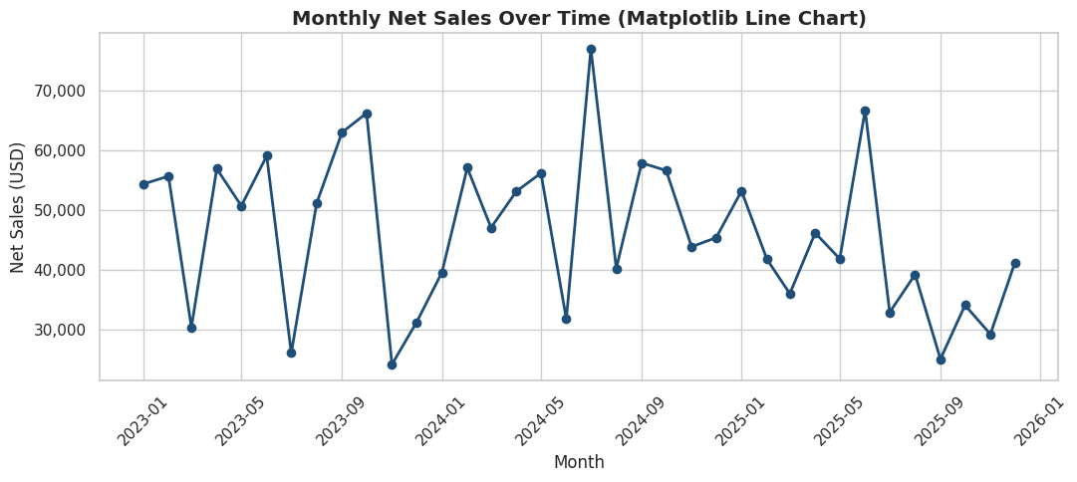

4.2 Vertical bar chart
Line by line:
- ax.bar(categories, values, color=...) draws one vertical bar per category.
- ax.bar_label(bars, fmt=...) writes the value on top of each bar automatically.
Code
fig, ax = plt.subplots(figsize=(10, 6))
bars = ax.bar(cat_sales.index, cat_sales.values, color='#2E86AB')
ax.set_title('Total Net Sales by Product Category (Matplotlib Bar Chart)')
ax.set_xlabel('Product Category')
ax.set_ylabel('Net Sales (USD)')
ax.bar_label(bars, fmt='{:,.0f}', padding=3)
plt.xticks(rotation=20)
fig.tight_layout()
plt.show()

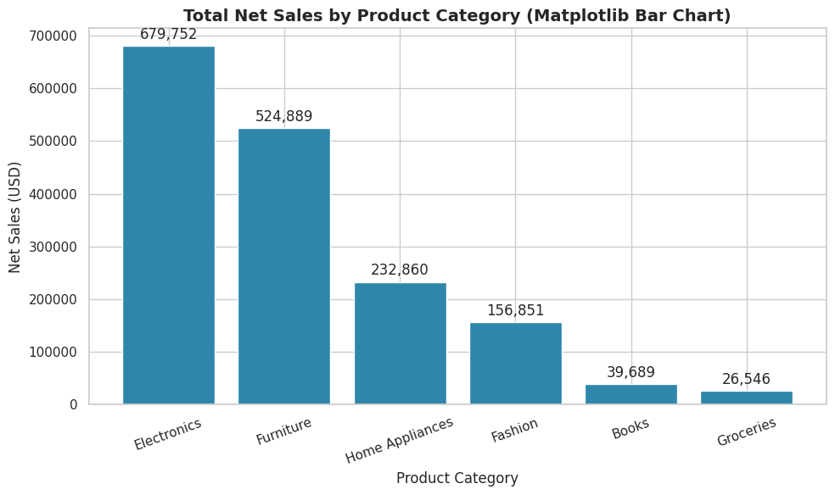

4.3 Horizontal bar chart
Line by line:
- ax.barh(categories, values) draws horizontal bars - often more readable than vertical bars
when category labels are long, since the text reads left to right naturally.
Code
fig, ax = plt.subplots(figsize=(9, 5))
ax.barh(region_sales.index, region_sales.values, color='#A23B72')
ax.set_title('Total Net Sales by Region (Matplotlib Horizontal Bar Chart)')
ax.set_xlabel('Net Sales (USD)')
ax.invert_yaxis()
fig.tight_layout()
plt.show()

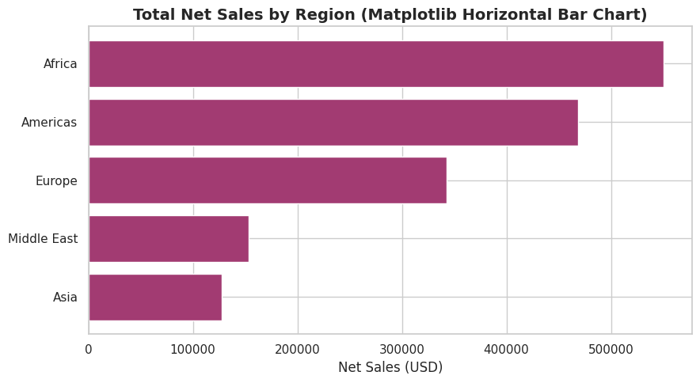

4.4 Stacked bar chart
Line by line:
- Plotting a second ax.bar(..., bottom=first_values) on top of the first stacks the two series,
since bottom tells Matplotlib where the new bars should start rather than starting them at zero.
Code
years = country_year.columns.tolist()
top_countries = plot_df.groupby('Country')['NetSales'].sum().nlargest(5).index
stack_data = country_year.loc[top_countries]

fig, ax = plt.subplots(figsize=(10, 6))
bottom = np.zeros(len(stack_data))
colors = plt.cm.viridis(np.linspace(0.15, 0.85, len(years)))
for year, color in zip(years, colors):
ax.bar(stack_data.index, stack_data[year], bottom=bottom, label=str(year), color=color)
bottom += stack_data[year].values

ax.set_title('Net Sales by Country, Stacked by Year (Matplotlib Stacked Bar Chart)')
ax.set_ylabel('Net Sales (USD)')
ax.legend(title='Year')
plt.xticks(rotation=20)
fig.tight_layout()
plt.show()

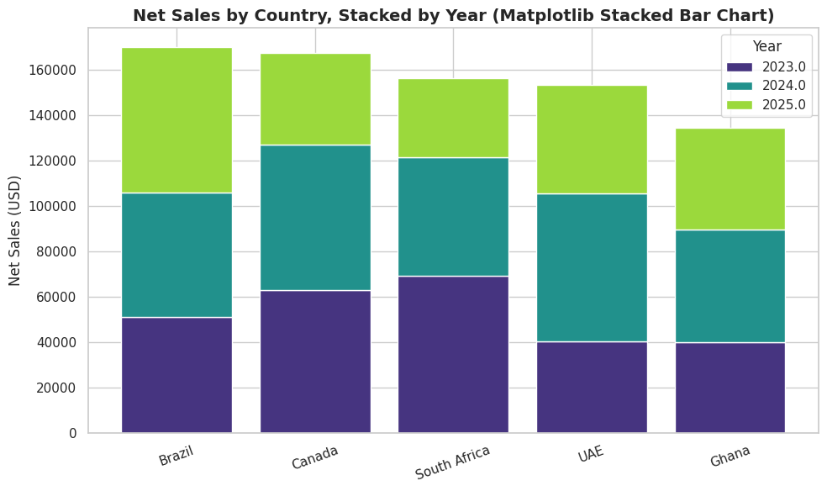

4.5 Grouped (clustered) bar chart
Line by line:
- To place bars for different years side by side rather than stacked, we offset each year's bar
positions by a small amount using np.arange and a width calculated from the number of groups.
Code
x = np.arange(len(stack_data))
width = 0.8 / len(years)

fig, ax = plt.subplots(figsize=(11, 6))
for i, (year, color) in enumerate(zip(years, colors)):
ax.bar(x + i * width, stack_data[year], width=width, label=str(year), color=color)

ax.set_title('Net Sales by Country and Year (Matplotlib Grouped Bar Chart)')
ax.set_xticks(x + width * (len(years) - 1) / 2)
ax.set_xticklabels(stack_data.index, rotation=20)
ax.set_ylabel('Net Sales (USD)')
ax.legend(title='Year')
fig.tight_layout()
plt.show()

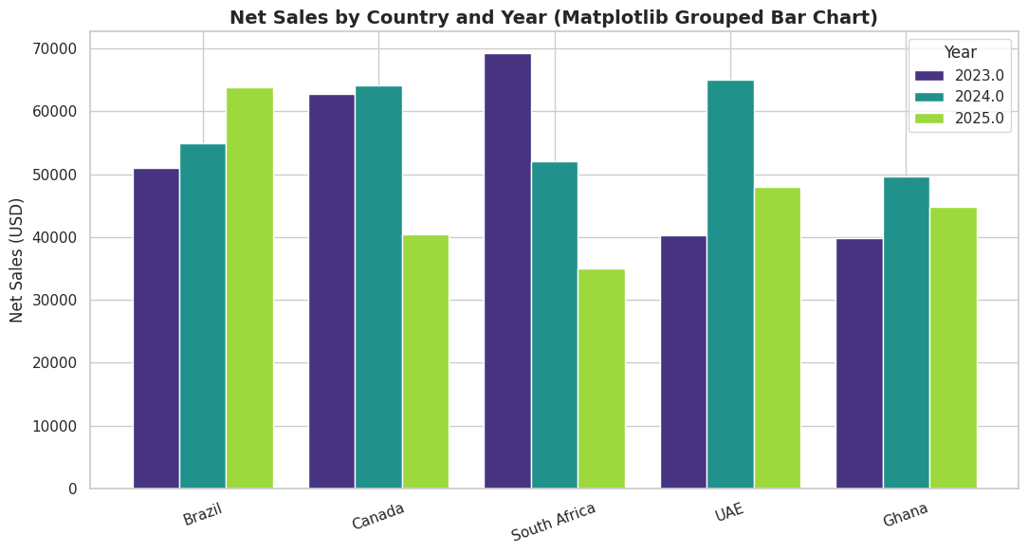

4.6 Histogram
Line by line:
- ax.hist(values, bins=30) splits the numeric range into 30 equal-width bins and counts how
many observations fall in each - the standard chart for seeing the shape of a distribution.
Code
fig, ax = plt.subplots(figsize=(10, 6))
ax.hist(plot_df['UnitPrice'].dropna(), bins=30, color='#F18F01', edgecolor='white')
ax.set_title('Distribution of Unit Price (Matplotlib Histogram)')
ax.set_xlabel('Unit Price (USD)')
ax.set_ylabel('Frequency')
fig.tight_layout()
plt.show()

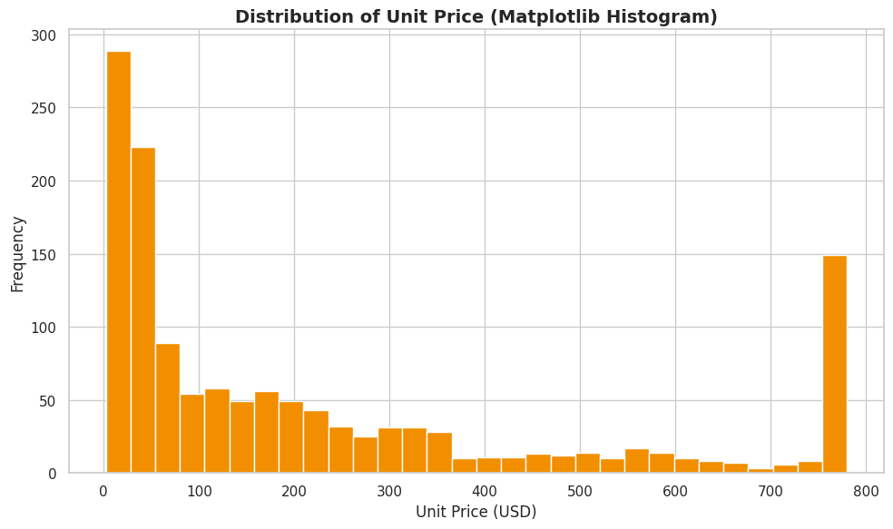

4.7 Box plot
Line by line:
- ax.boxplot([...], labels=[...]) draws one box-and-whisker summary (median, quartiles, whiskers,
outlier points) per group passed in - a compact way to compare spread and outliers across categories.
Code
box_data = [plot_df.loc[plot_df['ProductCategory'] == cat, 'NetSales'].dropna()
for cat in cat_sales.index]

fig, ax = plt.subplots(figsize=(10, 6))
ax.boxplot(box_data, labels=cat_sales.index, showmeans=True)
ax.set_title('Net Sales Spread by Product Category (Matplotlib Box Plot)')
ax.set_ylabel('Net Sales (USD)')
plt.xticks(rotation=20)
fig.tight_layout()
plt.show()

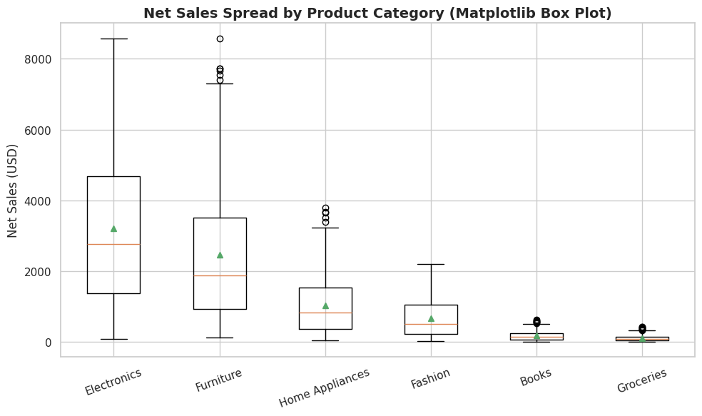

4.8 Scatter plot (and bubble chart)
Line by line:
- ax.scatter(x, y) plots one point per row, for seeing the relationship between two numeric variables.
- Passing s= (size) mapped from a third numeric variable and c= (colour) mapped from a fourth
turns the same chart into a bubble chart, encoding up to four variables in one plot.
Code
sample = plot_df.dropna(subset=['UnitPrice', 'NetSales', 'Quantity', 'Rating']).sample(
n=min(300, len(plot_df)), random_state=1)

fig, ax = plt.subplots(figsize=(10, 6))
scatter = ax.scatter(sample['UnitPrice'], sample['NetSales'],
s=sample['Quantity'].astype(float) * 15,
c=sample['Rating'].astype(float), cmap='viridis', alpha=0.7, edgecolor='white')
ax.set_title('Unit Price vs Net Sales, Sized by Quantity, Coloured by Rating (Matplotlib Bubble Chart)')
ax.set_xlabel('Unit Price (USD)')
ax.set_ylabel('Net Sales (USD)')
cbar = fig.colorbar(scatter, ax=ax)
cbar.set_label('Rating')
fig.tight_layout()
plt.show()

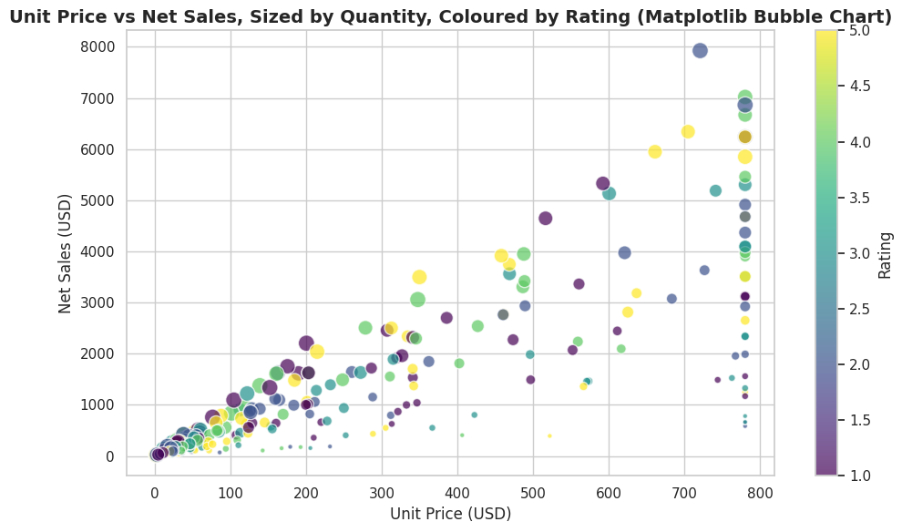

4.9 Pie chart
Line by line:
- ax.pie(values, labels=..., autopct=...) draws a pie chart; autopct formats the percentage
label shown inside each slice. Pie charts read best with five or fewer slices, so we group
smaller categories together first where necessary.
Code
fig, ax = plt.subplots(figsize=(8, 8))
ax.pie(status_counts.values, labels=status_counts.index, autopct='%1.1f%%',
startangle=90, colors=plt.cm.Set2.colors, wedgeprops={'edgecolor': 'white'})
ax.set_title('Share of Orders by Order Status (Matplotlib Pie Chart)')
ax.axis('equal')
plt.show()

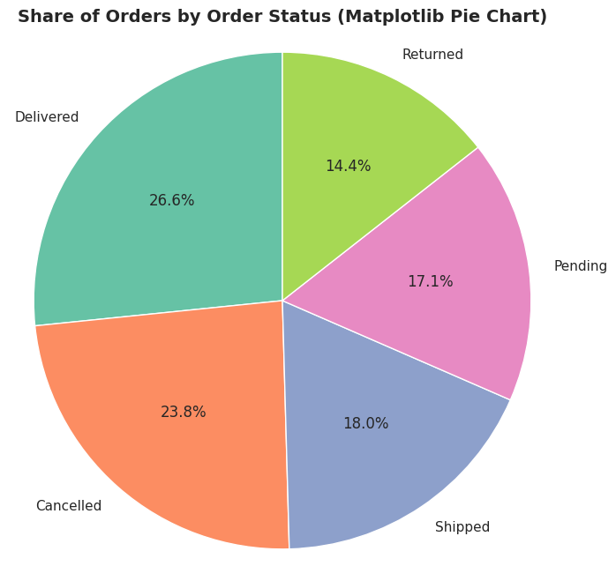

4.10 Area chart and stacked area chart
Line by line:
- ax.fill_between(x, y) shades the area under a line - a single-series area chart.
- ax.stackplot(x, y1, y2, ..., labels=[...]) draws several series stacked on top of one another,
useful for showing how a total is composed of parts over time.
Code
fig, ax = plt.subplots(figsize=(11, 5))
ax.fill_between(monthly_sales_plot.index, monthly_sales_plot.values, color='#2E86AB', alpha=0.4)
ax.plot(monthly_sales_plot.index, monthly_sales_plot.values, color='#2E86AB', linewidth=2)
ax.set_title('Monthly Net Sales (Matplotlib Area Chart)')
ax.set_ylabel('Net Sales (USD)')
plt.xticks(rotation=45)
fig.tight_layout()
plt.show()

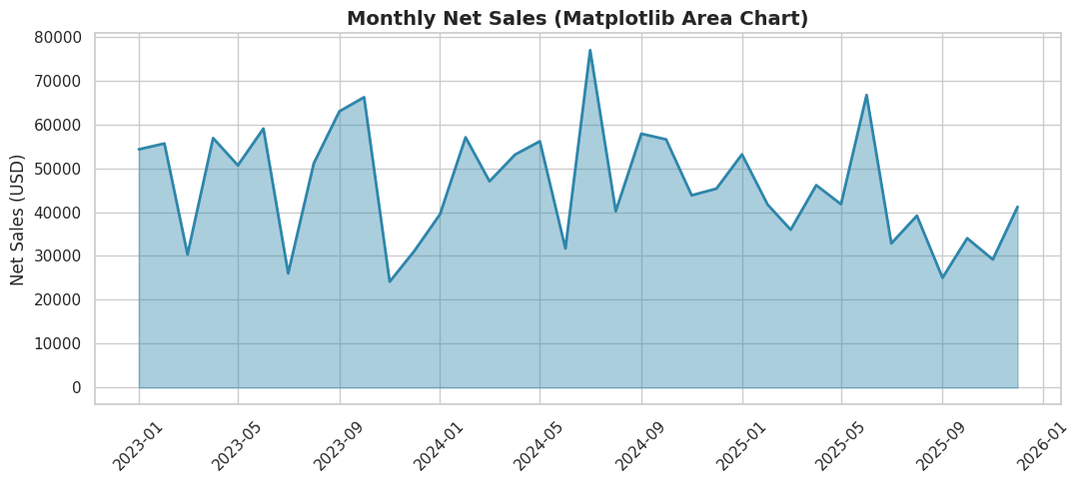

Code
monthly_by_cat = plot_df.set_index('OrderDate').groupby('ProductCategory')['NetSales'].resample('QE').sum().unstack(0).fillna(0)

fig, ax = plt.subplots(figsize=(11, 6))
ax.stackplot(monthly_by_cat.index, [monthly_by_cat[c] for c in monthly_by_cat.columns],
labels=monthly_by_cat.columns, alpha=0.85)
ax.set_title('Quarterly Net Sales by Category (Matplotlib Stacked Area Chart)')
ax.set_ylabel('Net Sales (USD)')
ax.legend(loc='upper left', fontsize=8)
plt.xticks(rotation=45)
fig.tight_layout()
plt.show()

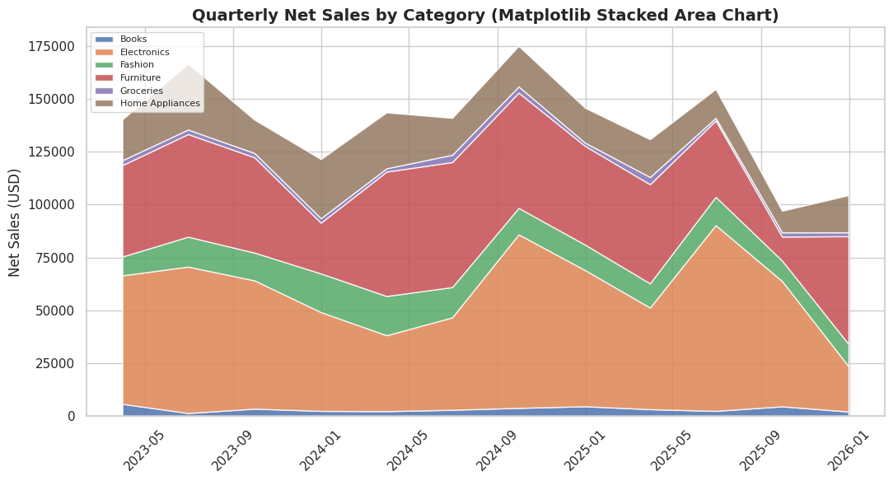

4.11 Step plot
Line by line:
- ax.step(x, y, where='mid') draws a stair-step line instead of a smooth diagonal line between
points - appropriate when a value is constant between observations, such as a monthly target
that only changes once a month.
Code
fig, ax = plt.subplots(figsize=(11, 5))
ax.step(monthly_sales_plot.index, monthly_sales_plot.values, where='mid', color='#C73E1D', linewidth=2)
ax.set_title('Monthly Net Sales (Matplotlib Step Plot)')
ax.set_ylabel('Net Sales (USD)')
plt.xticks(rotation=45)
fig.tight_layout()
plt.show()

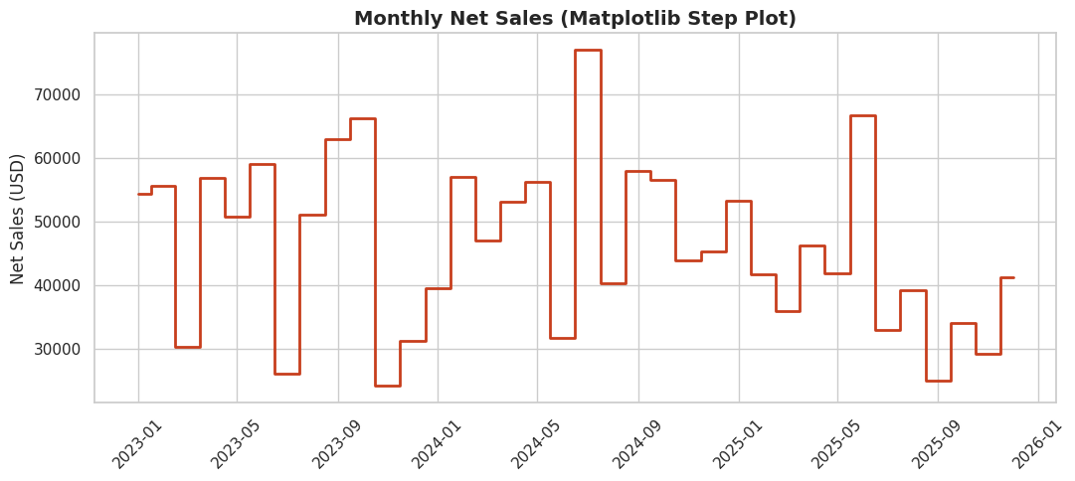

4.12 Stem plot
Line by line:
- ax.stem(x, y) draws a vertical line (stem) from zero up to each data point with a marker at
the top - useful for emphasising discrete, individual values rather than a continuous trend.
Code
last_12 = monthly_sales_plot.tail(12)
fig, ax = plt.subplots(figsize=(11, 5))
ax.stem(range(len(last_12)), last_12.values)
ax.set_xticks(range(len(last_12)))
ax.set_xticklabels([d.strftime('%b %Y') for d in last_12.index], rotation=45)
ax.set_title('Net Sales for the Last 12 Months (Matplotlib Stem Plot)')
ax.set_ylabel('Net Sales (USD)')
fig.tight_layout()
plt.show()

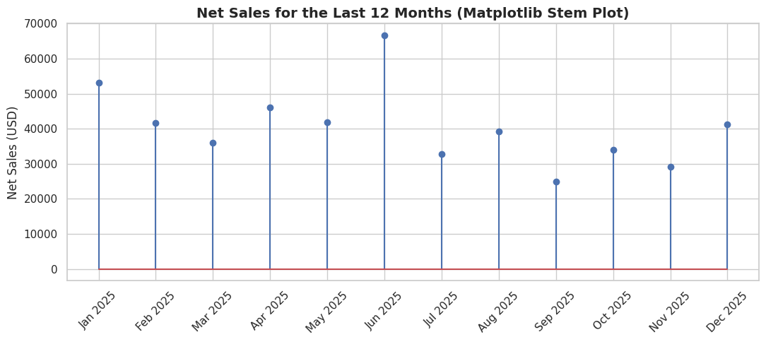

4.13 Error bar plot
Line by line:
- ax.errorbar(x, y, yerr=...) plots a point for each category with a vertical bar showing
uncertainty (here, the standard deviation of net sales within each category) - communicating
not just the average but how much it varies.
Code
cat_stats = plot_df.groupby('ProductCategory')['NetSales'].agg(['mean', 'std']).sort_values('mean', ascending=False)

fig, ax = plt.subplots(figsize=(10, 6))
ax.errorbar(cat_stats.index, cat_stats['mean'], yerr=cat_stats['std'], fmt='o', capsize=6,
color='#1F4E78', ecolor='#A23B72', markersize=8)
ax.set_title('Average Net Sales by Category with Standard Deviation (Matplotlib Error Bar Plot)')
ax.set_ylabel('Net Sales (USD)')
plt.xticks(rotation=20)
fig.tight_layout()
plt.show()

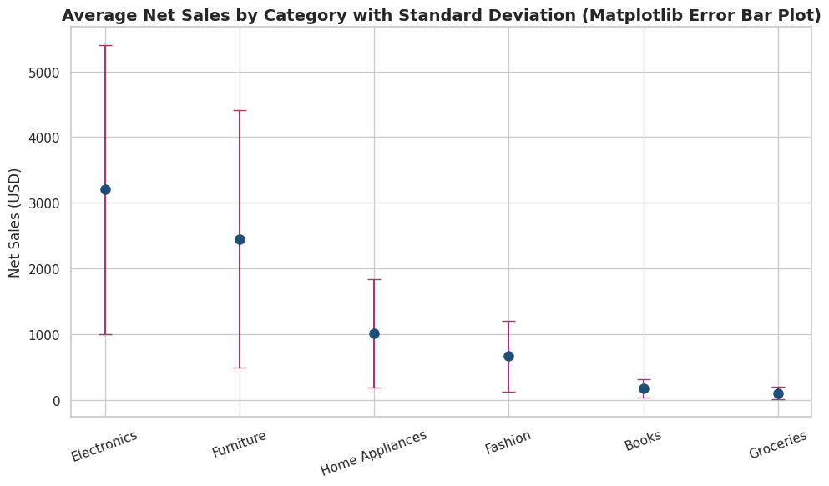

4.14 Dual axis (twin axes) chart
Line by line:
- ax2 = ax1.twinx() creates a second y-axis that shares the same x-axis as the first - used
when plotting two series with very different scales (here, sales in dollars against an order count).
Code
monthly_orders = plot_df.set_index('OrderDate').sort_index()['OrderID'].resample('MS').count()

fig, ax1 = plt.subplots(figsize=(11, 6))
ax1.plot(monthly_sales_plot.index, monthly_sales_plot.values, color='#1F4E78', marker='o', label='Net Sales')
ax1.set_xlabel('Month')
ax1.set_ylabel('Net Sales (USD)', color='#1F4E78')
ax1.tick_params(axis='y', labelcolor='#1F4E78')

ax2 = ax1.twinx()
ax2.plot(monthly_orders.index, monthly_orders.values, color='#C73E1D', marker='s', label='Order Count')
ax2.set_ylabel('Number of Orders', color='#C73E1D')
ax2.tick_params(axis='y', labelcolor='#C73E1D')

ax1.set_title('Monthly Net Sales and Order Count (Matplotlib Dual Axis Chart)')
plt.xticks(rotation=45)
fig.tight_layout()
plt.show()

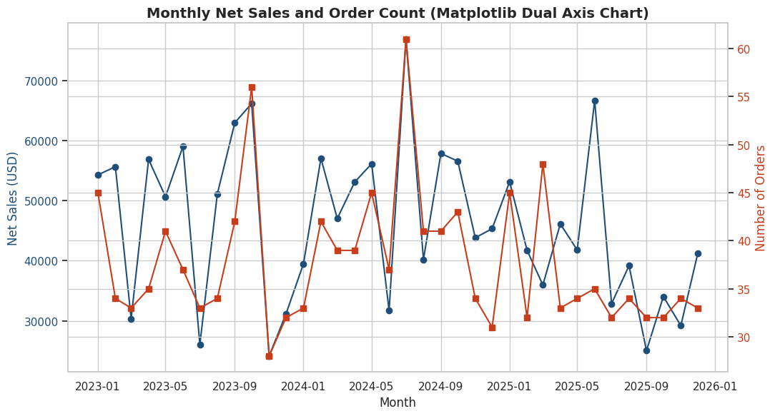

4.15 Subplots (multi-panel figure)
Line by line:
- plt.subplots(nrows, ncols, figsize=...) returns a grid of axes objects at once, letting several
related charts share one figure - the basis of a simple dashboard.
Code
fig, axes = plt.subplots(2, 2, figsize=(13, 10))

axes[0, 0].bar(cat_sales.index, cat_sales.values, color='#2E86AB')
axes[0, 0].set_title('Net Sales by Category')
axes[0, 0].tick_params(axis='x', rotation=30)

axes[0, 1].hist(plot_df['UnitPrice'].dropna(), bins=25, color='#F18F01')
axes[0, 1].set_title('Unit Price Distribution')

axes[1, 0].plot(monthly_sales_plot.index, monthly_sales_plot.values, color='#1F4E78', marker='o')
axes[1, 0].set_title('Monthly Net Sales Trend')
axes[1, 0].tick_params(axis='x', rotation=45)

axes[1, 1].pie(status_counts.values, labels=status_counts.index, autopct='%1.0f%%', colors=plt.cm.Set2.colors)
axes[1, 1].set_title('Order Status Share')

fig.suptitle('Retail Sales - Executive Summary (Matplotlib Subplots)', fontsize=16, fontweight='bold')
fig.tight_layout(rect=[0, 0, 1, 0.96])
plt.show()

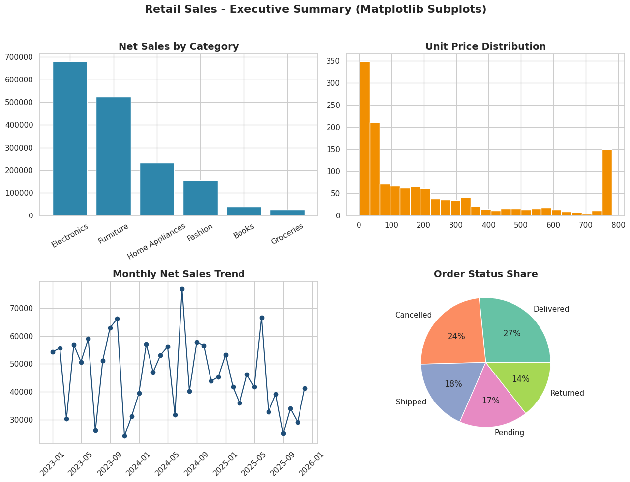

4.16 Saving a chart to a file
Line by line:
- fig.savefig(path, dpi=200, bbox_inches='tight') exports the current figure to an image file
at high resolution, trimming excess whitespace - the standard way to produce a chart for a
slide deck or a Word document (used later to build the training manual).
Code
fig, ax = plt.subplots(figsize=(10, 6))
bars = ax.bar(cat_sales.index, cat_sales.values, color='#2E86AB')
ax.set_title('Total Net Sales by Product Category')
ax.bar_label(bars, fmt='{:,.0f}')
plt.xticks(rotation=20)
fig.tight_layout()
fig.savefig('chart_category_sales.png', dpi=200, bbox_inches='tight')
plt.show()
print('Chart saved to chart_category_sales.png')

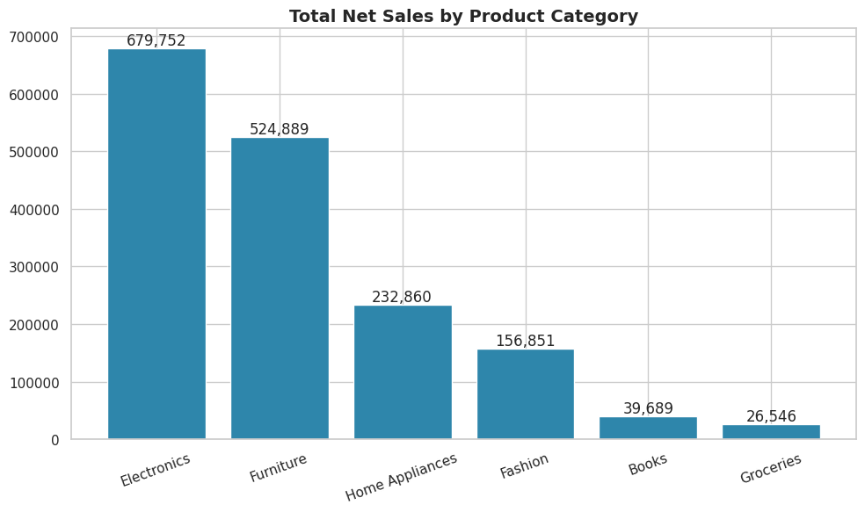

PART 5 - Data Visualization with Seaborn
Seaborn is built on top of Matplotlib and is specialised for statistical graphics: it works
directly with tidy (long-format) DataFrames and columns of category labels, and it computes
many statistics (means, confidence intervals, regression lines, densities) automatically.
This part works through every major Seaborn chart type on the same cleaned data.

5.1 Scatter plot
Line by line:
- sns.scatterplot(data=df, x=, y=, hue=, size=) plots one point per row directly from a
DataFrame; hue colours points by a category, size scales points by a numeric column - both
handled automatically, including drawing the legend.
Code
fig, ax = plt.subplots(figsize=(10, 6))
sns.scatterplot(data=sample, x='UnitPrice', y='NetSales', hue='ProductCategory', size='Quantity',
sizes=(20, 200), alpha=0.75, ax=ax)
ax.set_title('Unit Price vs Net Sales by Category (Seaborn Scatter Plot)')
ax.legend(bbox_to_anchor=(1.02, 1), loc='upper left', fontsize=8)
fig.tight_layout()
plt.show()

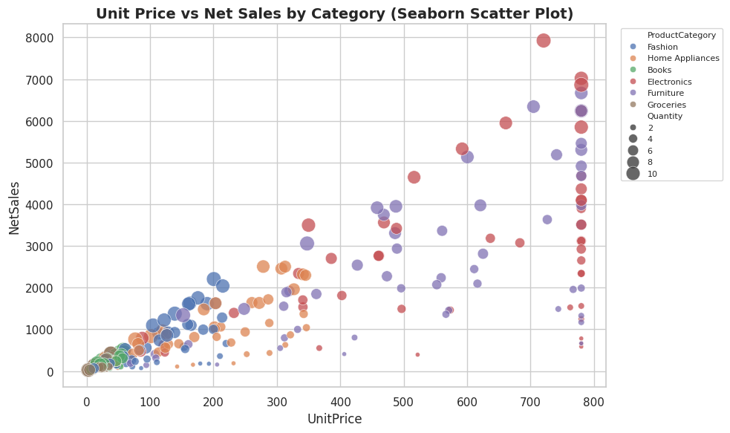

5.2 Line plot
Line by line:
- sns.lineplot(data=df, x=, y=, hue=) draws a line per group and, when there are multiple
observations per x value, automatically shades a confidence interval band around the line.
Code
monthly_cat = plot_df.set_index('OrderDate').groupby('ProductCategory')['NetSales'].resample('MS').sum().reset_index()

fig, ax = plt.subplots(figsize=(12, 6))
sns.lineplot(data=monthly_cat, x='OrderDate', y='NetSales', hue='ProductCategory', marker='o', ax=ax)
ax.set_title('Monthly Net Sales by Category (Seaborn Line Plot)')
ax.legend(bbox_to_anchor=(1.02, 1), loc='upper left', fontsize=8)
plt.xticks(rotation=45)
fig.tight_layout()
plt.show()

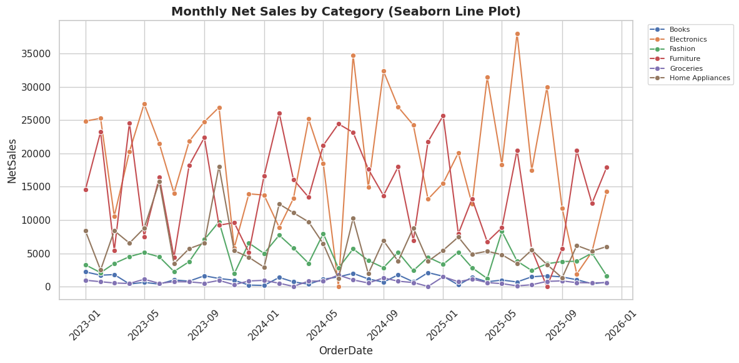

5.3 Bar plot
Line by line:
- sns.barplot(data=df, x=, y=, estimator=, errorbar=) groups the data by x and plots the
aggregated value (mean, by default) as a bar, with an error bar showing uncertainty around
that estimate - Seaborn does the grouping and aggregating internally, unlike Matplotlib's bar.
Code
fig, ax = plt.subplots(figsize=(10, 6))
sns.barplot(data=plot_df, x='ProductCategory', y='NetSales', estimator='mean', errorbar='sd',
hue='ProductCategory', legend=False, palette='crest', ax=ax)
ax.set_title('Average Net Sales by Category, with Standard Deviation (Seaborn Bar Plot)')
plt.xticks(rotation=20)
fig.tight_layout()
plt.show()

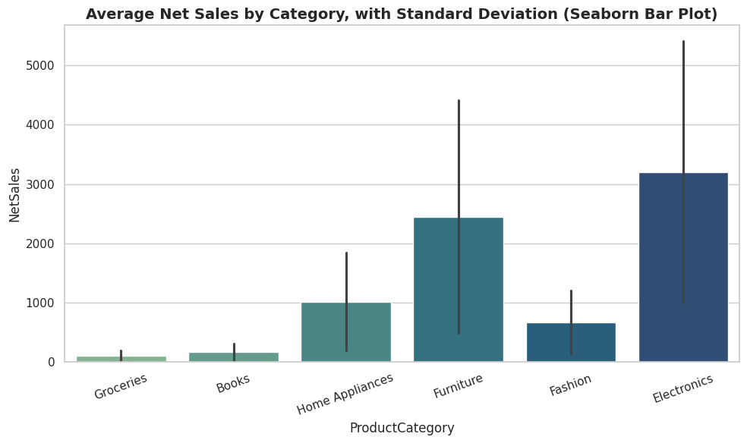

5.4 Count plot
Line by line:
- sns.countplot(data=df, x=) counts how many rows fall into each category and plots the
counts as bars - the Seaborn equivalent of value_counts().plot(kind='bar'), with cleaner defaults.
Code
fig, ax = plt.subplots(figsize=(9, 6))
sns.countplot(data=plot_df, x='OrderStatus', order=plot_df['OrderStatus'].value_counts().index,
hue='OrderStatus', legend=False, palette='flare', ax=ax)
ax.set_title('Number of Orders by Status (Seaborn Count Plot)')
plt.xticks(rotation=20)
fig.tight_layout()
plt.show()

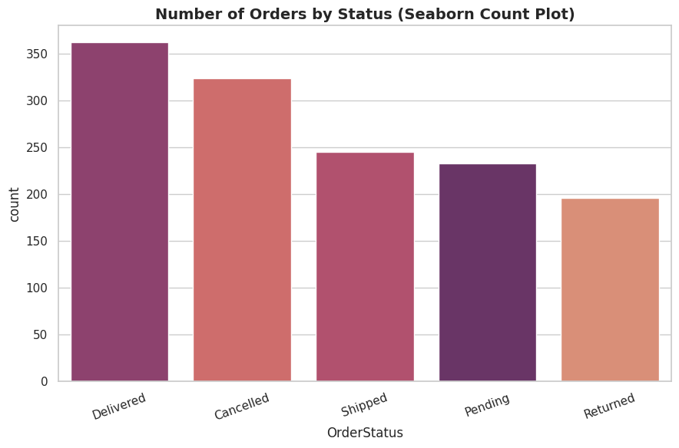

5.5 Box plot
Line by line:
- sns.boxplot(data=df, x=, y=, hue=) draws the same box-and-whisker summaries as Matplotlib's
boxplot, but reads directly from a tidy DataFrame and can split each box further by a hue category.
Code
fig, ax = plt.subplots(figsize=(11, 6))
sns.boxplot(data=plot_df, x='ProductCategory', y='NetSales', hue='Gender', palette='Set2', ax=ax)
ax.set_title('Net Sales Spread by Category and Gender (Seaborn Box Plot)')
plt.xticks(rotation=20)
fig.tight_layout()
plt.show()

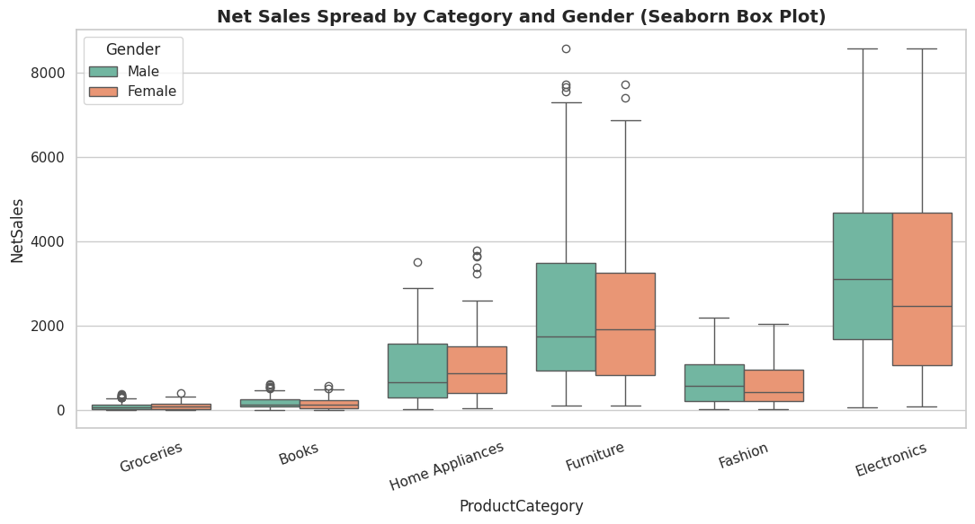

5.6 Violin plot
Line by line:
- sns.violinplot(...) combines a box plot with a rotated, mirrored density plot on each side,
showing the full shape of the distribution (where values cluster) as well as the summary
statistics a box plot shows.
Code
fig, ax = plt.subplots(figsize=(11, 6))
sns.violinplot(data=plot_df, x='ProductCategory', y='NetSales', hue='ProductCategory',
legend=False, palette='mako', ax=ax)
ax.set_title('Net Sales Distribution Shape by Category (Seaborn Violin Plot)')
plt.xticks(rotation=20)
fig.tight_layout()
plt.show()

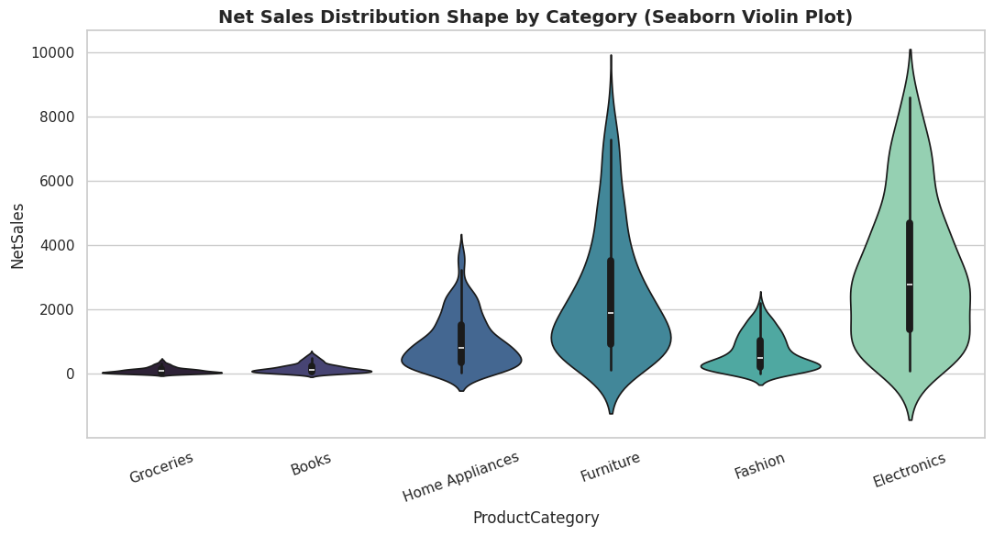

5.7 Strip plot
Line by line:
- sns.stripplot(...) plots every individual observation as a small, slightly jittered dot along
a categorical axis - useful for seeing the raw data points and the sample size behind a summary chart.
Code
fig, ax = plt.subplots(figsize=(11, 6))
sns.stripplot(data=sample, x='ProductCategory', y='NetSales', hue='ProductCategory',
legend=False, alpha=0.6, palette='deep', ax=ax)
ax.set_title('Individual Sales Observations by Category (Seaborn Strip Plot)')
plt.xticks(rotation=20)
fig.tight_layout()
plt.show()

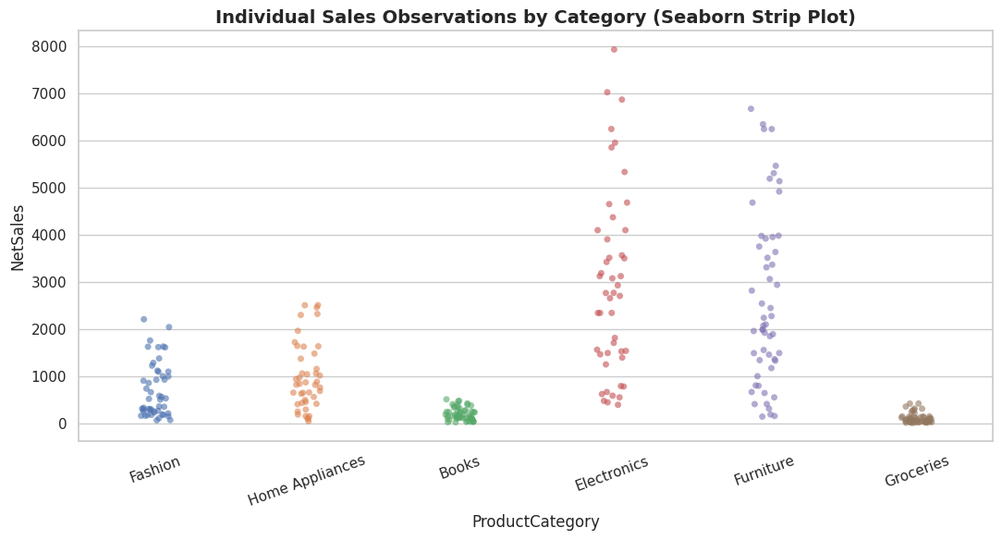

5.8 Swarm plot
Line by line:
- sns.swarmplot(...) is like a strip plot, but it arranges points so they never overlap,
giving a clearer picture of density at each value - best used on a modestly sized sample, as shown here.
Code
small_sample = plot_df.dropna(subset=['NetSales']).sample(n=min(150, len(plot_df)), random_state=2)

fig, ax = plt.subplots(figsize=(11, 6))
sns.swarmplot(data=small_sample, x='ProductCategory', y='NetSales', hue='ProductCategory',
legend=False, size=4, palette='viridis', ax=ax)
ax.set_title('Sales Observations by Category, Non-Overlapping (Seaborn Swarm Plot)')
plt.xticks(rotation=20)
fig.tight_layout()
plt.show()

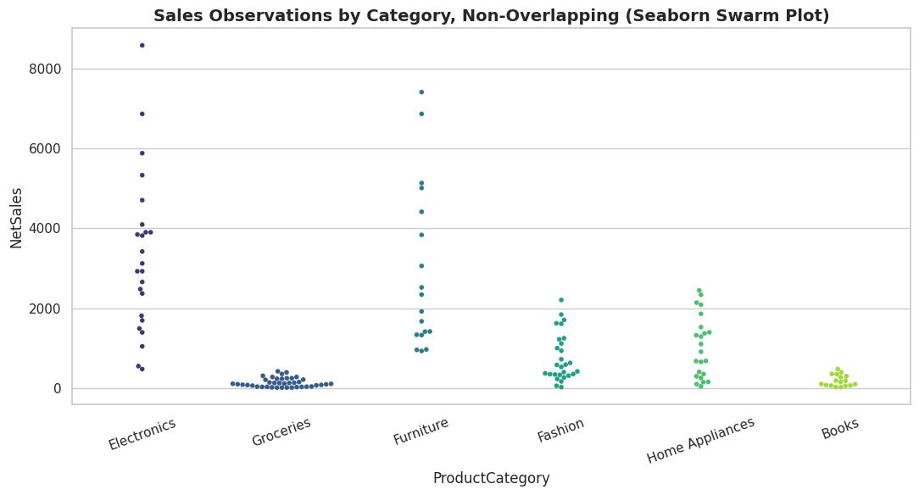

5.9 Histogram (histplot) with KDE
Line by line:
- sns.histplot(data=df, x=, kde=True, hue=) draws a histogram and can overlay a smoothed
kernel density estimate (KDE) line on top, and can split the histogram by a category automatically.
Code
fig, ax = plt.subplots(figsize=(10, 6))
sns.histplot(data=plot_df, x='UnitPrice', kde=True, bins=30, color='#2E86AB', ax=ax)
ax.set_title('Distribution of Unit Price with Density Curve (Seaborn Histogram)')
fig.tight_layout()
plt.show()

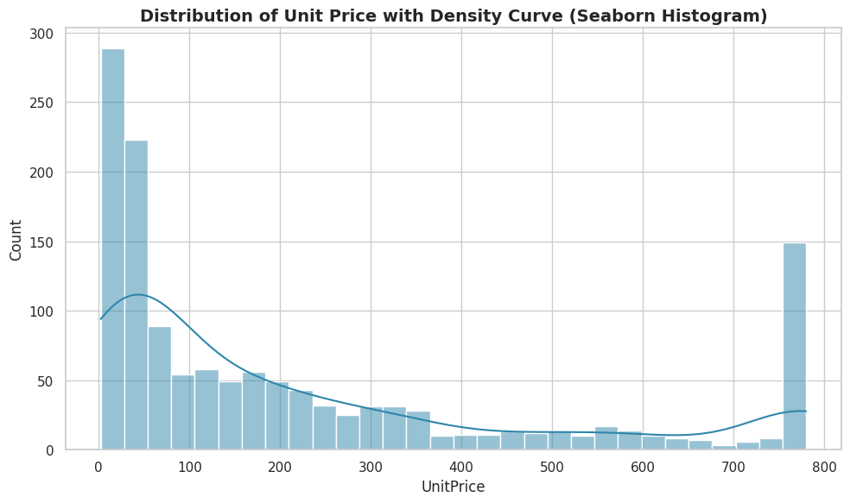

5.10 KDE plot
Line by line:
- sns.kdeplot(data=df, x=, hue=, fill=True) plots only the smoothed density curve (no bars),
making it easy to compare the shape of several distributions overlaid on one chart.
Code
fig, ax = plt.subplots(figsize=(10, 6))
sns.kdeplot(data=plot_df, x='NetSales', hue='ProductCategory', fill=True, alpha=0.25,
common_norm=False, ax=ax)
ax.set_title('Net Sales Density by Category (Seaborn KDE Plot)')
ax.set_xlim(0, plot_df['NetSales'].quantile(0.98))
fig.tight_layout()
plt.show()

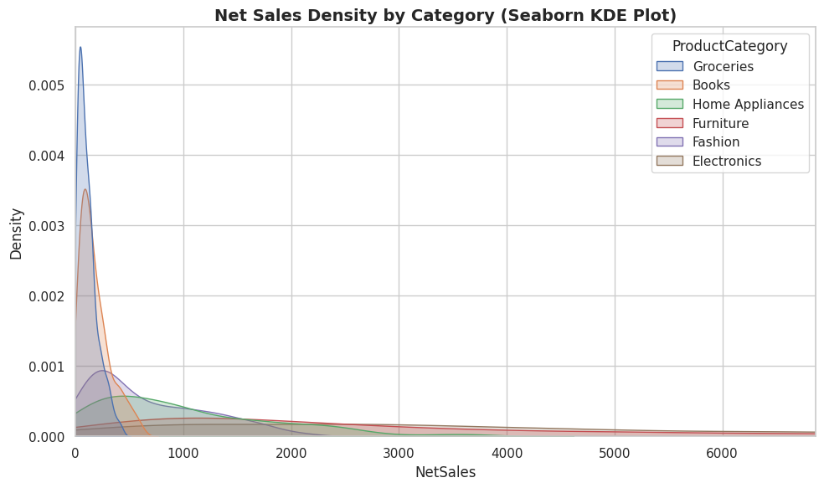

5.11 ECDF plot
Line by line:
- sns.ecdfplot(data=df, x=) plots the empirical cumulative distribution function - for any
point on the x-axis, the curve shows what proportion of observations are at or below it, a
precise alternative to reading percentiles off a histogram.
Code
fig, ax = plt.subplots(figsize=(10, 6))
sns.ecdfplot(data=plot_df, x='NetSales', hue='ProductCategory', ax=ax)
ax.set_title('Cumulative Distribution of Net Sales by Category (Seaborn ECDF Plot)')
ax.set_xlim(0, plot_df['NetSales'].quantile(0.98))
fig.tight_layout()
plt.show()

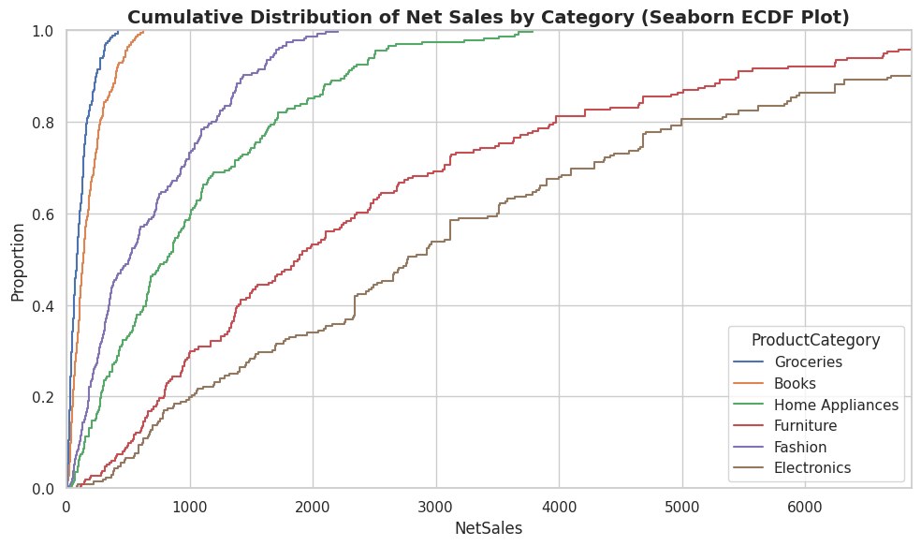

5.12 Heatmap (correlation matrix)
Line by line:
- df[cols].corr() computes the pairwise Pearson correlation between numeric columns.
- sns.heatmap(matrix, annot=True, cmap=...) colours each cell by its value and writes the
numeric value inside the cell - the standard way to visualise a correlation matrix at a glance.
Code
numeric_cols = ['Age', 'Quantity', 'UnitPrice', 'Discount', 'ShippingCost', 'Rating', 'NetSales']
corr_matrix = plot_df[numeric_cols].astype(float).corr()

fig, ax = plt.subplots(figsize=(9, 7))
sns.heatmap(corr_matrix, annot=True, fmt='.2f', cmap='coolwarm', center=0, square=True, ax=ax)
ax.set_title('Correlation Matrix of Numeric Variables (Seaborn Heatmap)')
fig.tight_layout()
plt.show()

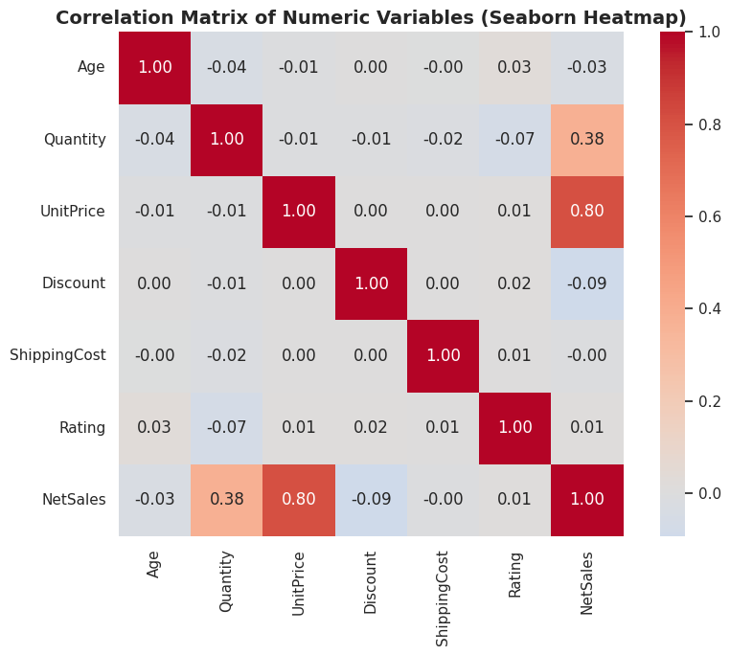

5.13 Heatmap (pivot table of category by month)
Line by line:
- The same sns.heatmap function is equally useful on any numeric grid, not only correlation
matrices - here it visualises a category-by-month sales pivot table, making seasonal patterns visible by colour.
Code
heat_pivot = pd.pivot_table(plot_df, values='NetSales', index='ProductCategory', columns='OrderMonth', aggfunc='sum', fill_value=0)
month_order = ['January','February','March','April','May','June','July','August','September','October','November','December']
heat_pivot = heat_pivot.reindex(columns=[m for m in month_order if m in heat_pivot.columns])

fig, ax = plt.subplots(figsize=(13, 6))
sns.heatmap(heat_pivot, cmap='YlGnBu', linewidths=0.5, ax=ax)
ax.set_title('Net Sales by Category and Month (Seaborn Heatmap)')
plt.xticks(rotation=45)
fig.tight_layout()
plt.show()

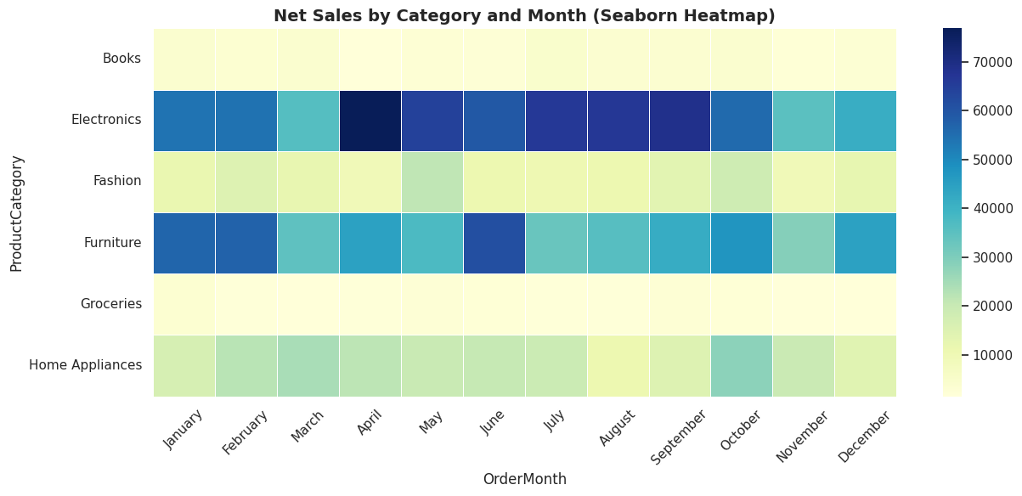

5.14 Regression plot (regplot / lmplot)
Line by line:
- sns.regplot(data=df, x=, y=) draws a scatter plot with a fitted linear regression line and
its confidence interval overlaid - useful for a quick visual read of whether two numeric
variables are related.
- sns.lmplot(...) does the same, but as a figure-level function that can automatically split
the regression into small multiples by a category using col= or row=.
Code
fig, ax = plt.subplots(figsize=(10, 6))
sns.regplot(data=sample, x='UnitPrice', y='NetSales', scatter_kws={'alpha': 0.4}, line_kws={'color': 'red'}, ax=ax)
ax.set_title('Unit Price vs Net Sales with Fitted Trend Line (Seaborn Regression Plot)')
fig.tight_layout()
plt.show()

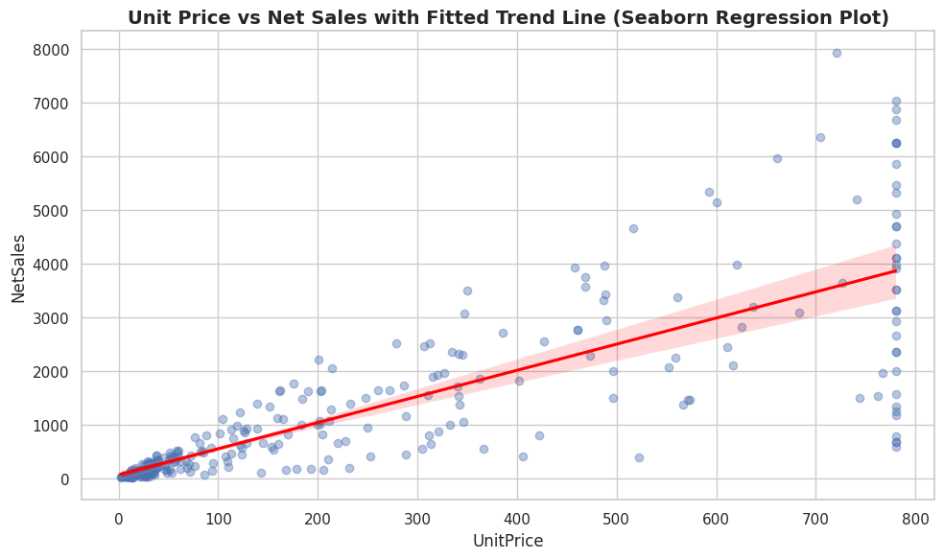

Code
g = sns.lmplot(data=sample, x='UnitPrice', y='NetSales', col='Gender', height=5, aspect=1,
scatter_kws={'alpha': 0.4})
g.figure.suptitle('Unit Price vs Net Sales by Gender (Seaborn lmplot, Small Multiples)', y=1.05)
plt.show()

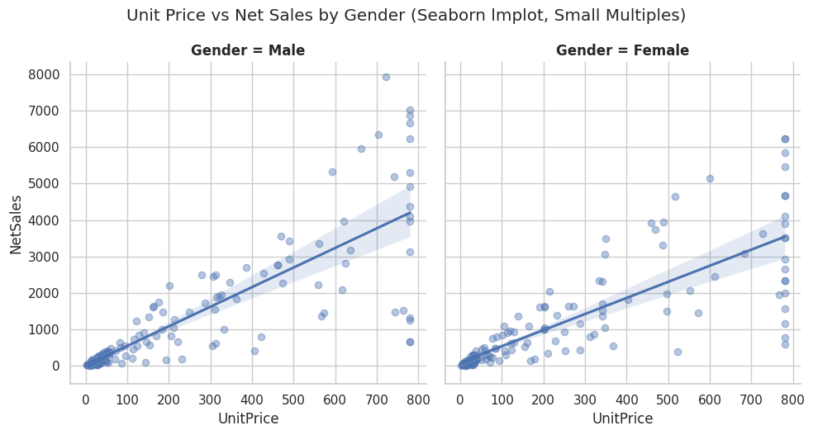

5.15 Pair plot
Line by line:
- sns.pairplot(data=df, vars=[...], hue=) builds a full grid of scatter plots for every pair of
chosen numeric variables, with histograms (or KDEs) on the diagonal - a fast way to scan
several relationships and distributions at once, split by a category colour.
Code
pair_sample = plot_df.dropna(subset=['UnitPrice', 'NetSales', 'Age', 'Rating']).sample(
n=min(250, len(plot_df)), random_state=3)

g = sns.pairplot(pair_sample, vars=['UnitPrice', 'NetSales', 'Age'], hue='ProductCategory',
diag_kind='kde', plot_kws={'alpha': 0.5, 's': 25}, height=2.6)
g.figure.suptitle('Pairwise Relationships Between Key Numeric Variables (Seaborn Pair Plot)', y=1.02)
plt.show()

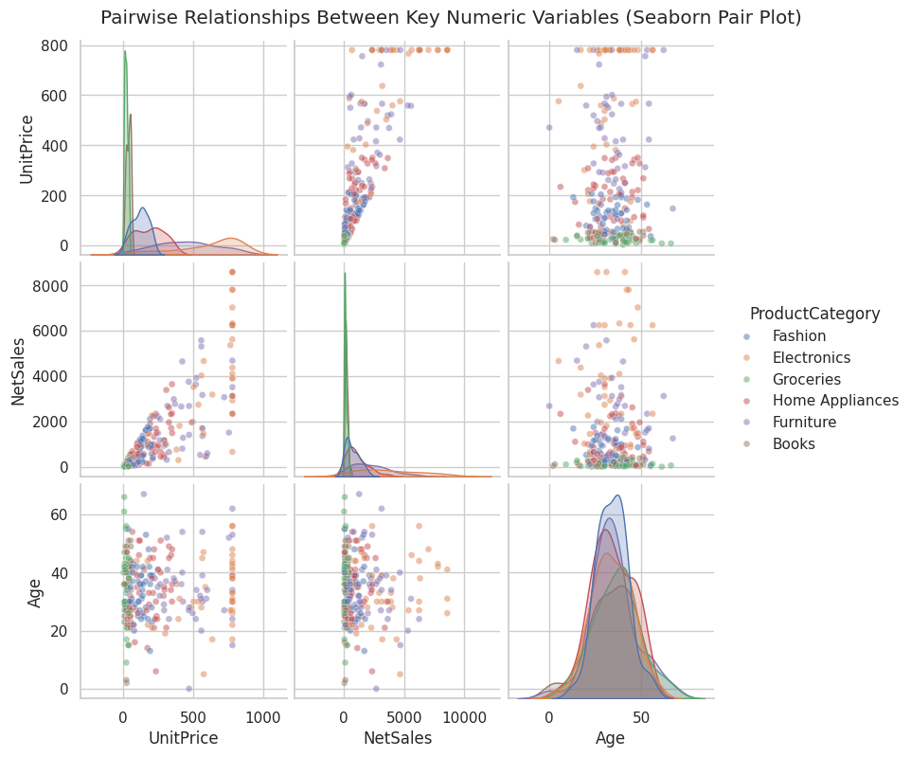

5.16 Joint plot
Line by line:
- sns.jointplot(data=df, x=, y=, kind=) combines a central scatter (or hex-bin, or KDE) plot
with the marginal distribution of each variable shown along the top and right edges - kind
can be 'scatter', 'hex', 'kde', 'reg', among others.
Code
g = sns.jointplot(data=sample, x='UnitPrice', y='NetSales', kind='hex', height=7, cmap='mako')
g.figure.suptitle('Unit Price vs Net Sales with Marginal Distributions (Seaborn Joint Plot)', y=1.02)
plt.show()

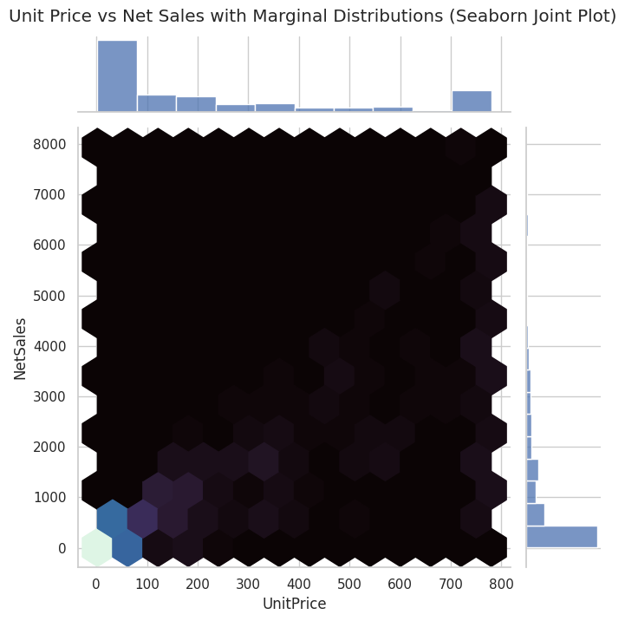

5.17 Cat plot (figure-level categorical plotting)
Line by line:
- sns.catplot(data=df, x=, y=, kind=, col=) is a figure-level function that can produce any of
Seaborn's categorical plot types ('bar', 'box', 'violin', 'strip', 'swarm', 'point')
and automatically split them into a grid of small multiples using col= or row=.
Code
g = sns.catplot(data=plot_df, x='OrderStatus', y='NetSales', kind='box', col='Region',
col_wrap=3, height=3.5, aspect=1.1, palette='Set3',
order=plot_df['OrderStatus'].value_counts().index)
g.figure.suptitle('Net Sales by Order Status, Split by Region (Seaborn Cat Plot)', y=1.02)
g.set_xticklabels(rotation=30)
plt.show()

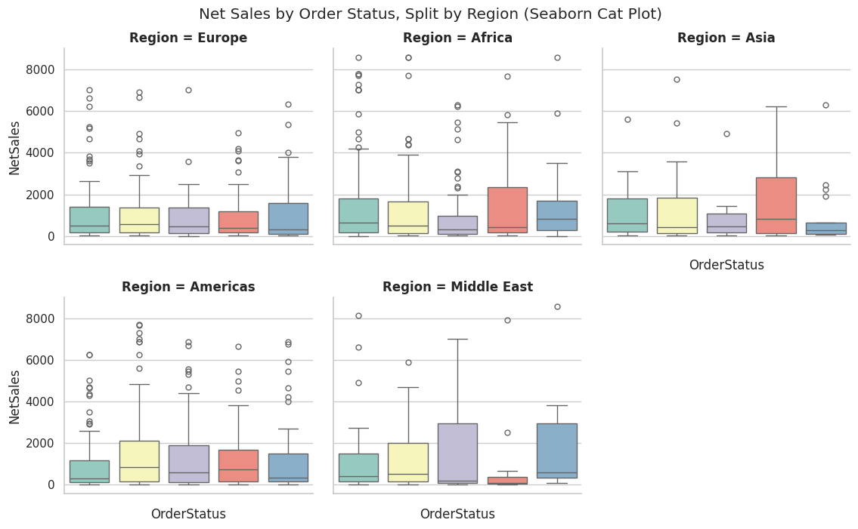

5.18 Point plot
Line by line:
- sns.pointplot(data=df, x=, y=, hue=) plots the mean of y for each category as a point,
connected by a line, with an error bar - useful for comparing trends across an ordered
category, such as spotting which day of the week performs best.
Code
weekday_order = ['Monday','Tuesday','Wednesday','Thursday','Friday','Saturday','Sunday']
fig, ax = plt.subplots(figsize=(10, 6))
sns.pointplot(data=plot_df, x='OrderWeekday', y='NetSales', order=weekday_order,
errorbar='sd', color='#1F4E78', ax=ax)
ax.set_title('Average Net Sales by Day of the Week (Seaborn Point Plot)')
plt.xticks(rotation=20)
fig.tight_layout()
plt.show()

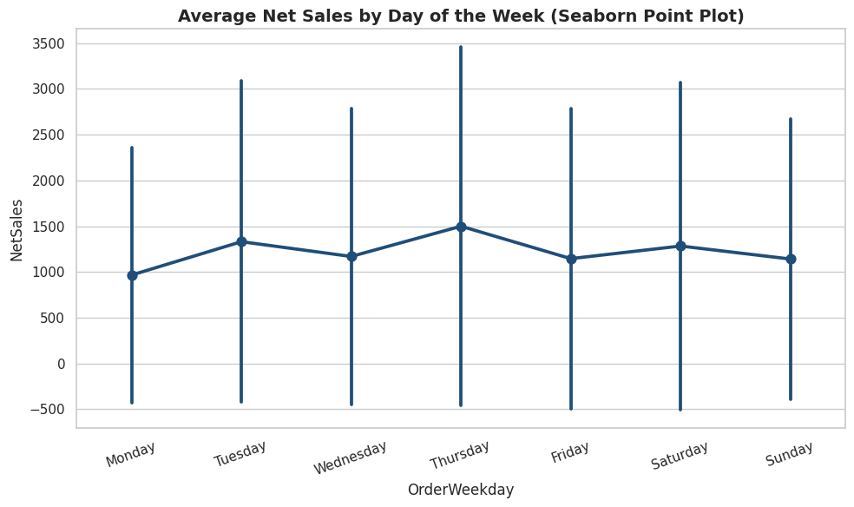

5.19 Facet grid
Line by line:
- sns.FacetGrid(data, col=, row=) builds an empty grid of small charts split by one or two
categorical variables.
- .map_dataframe(plotting_function, x=, y=) draws the same chart type into every cell of the grid.
- .add_legend() adds one shared legend for the whole grid.
Code
g = sns.FacetGrid(plot_df, col='ProductCategory', col_wrap=3, height=3.2, aspect=1.2)
g.map_dataframe(sns.histplot, x='NetSales', bins=20, color='#2E86AB')
g.set_titles(col_template='{col_name}')
g.figure.suptitle('Net Sales Distribution by Category (Seaborn Facet Grid)', y=1.03)
plt.show()

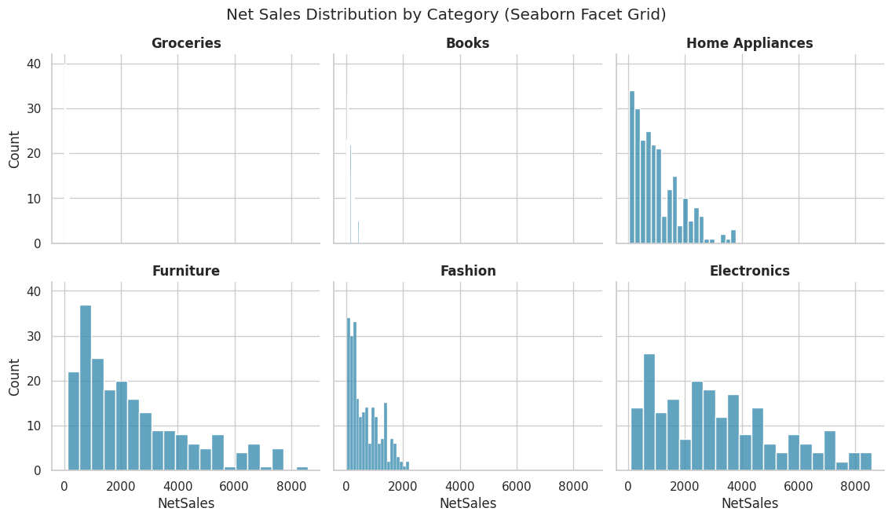

5.20 Styling: themes, palettes and context
Line by line:
- sns.set_theme(style=, palette=) (used at the very top of the notebook) sets the default
look for every chart drawn afterwards - style controls the background grid ('whitegrid',
'darkgrid', 'white', 'dark', 'ticks'), palette controls the default colour sequence.
- sns.set_context('talk') scales up font sizes and line widths for presentation use, versus
'paper' for compact, print-ready figures.
- These calls affect every subsequent chart, so they are normally set once, near the top of a
notebook or script - demonstrated here on one chart, then reset back to the notebook default.
Code
with sns.axes_style('darkgrid'), sns.plotting_context('talk'):
fig, ax = plt.subplots(figsize=(10, 6))
sns.barplot(data=plot_df, x='ProductCategory', y='NetSales', estimator='sum',
hue='ProductCategory', legend=False, palette='rocket', ax=ax)
ax.set_title('Total Net Sales by Category (Dark Grid Style, Talk Context)')
plt.xticks(rotation=20)
fig.tight_layout()
plt.show()

sns.set_theme(style='whitegrid', palette='deep') # restore the notebook default

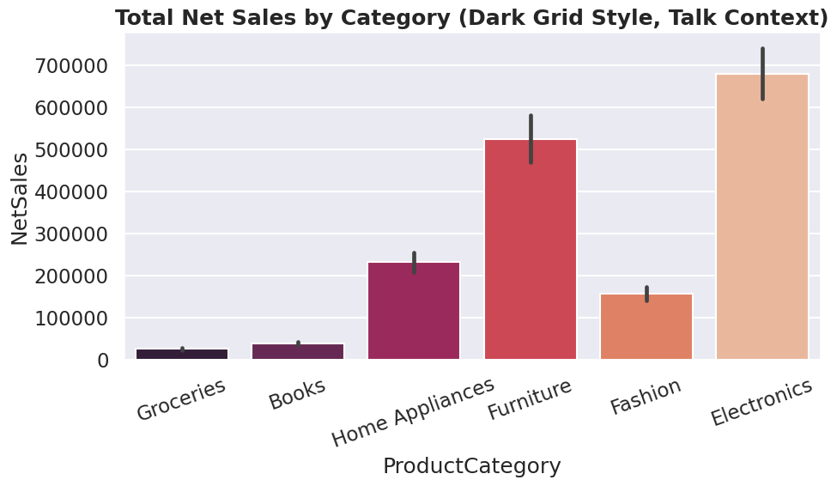

PART 6 - Bringing It Together: A Mini Dashboard
A short closing example that combines several of the techniques from this notebook - grouping,
pivoting, and a multi-panel Matplotlib and Seaborn figure - into one summary view, the kind of
output a training session usually ends on.
Code
fig = plt.figure(figsize=(15, 10))
gs = fig.add_gridspec(2, 2)

ax1 = fig.add_subplot(gs[0, 0])
ax1.plot(monthly_sales_plot.index, monthly_sales_plot.values, color='#1F4E78', marker='o')
ax1.set_title('Monthly Net Sales Trend')
ax1.tick_params(axis='x', rotation=45)

ax2 = fig.add_subplot(gs[0, 1])
sns.barplot(data=plot_df, x='ProductCategory', y='NetSales', estimator='sum',
hue='ProductCategory', legend=False, palette='crest', ax=ax2)
ax2.set_title('Total Net Sales by Category')
ax2.tick_params(axis='x', rotation=20)

ax3 = fig.add_subplot(gs[1, 0])
sns.boxplot(data=plot_df, x='Region', y='NetSales', hue='Region', legend=False, palette='Set2', ax=ax3)
ax3.set_title('Net Sales Spread by Region')
ax3.tick_params(axis='x', rotation=20)

ax4 = fig.add_subplot(gs[1, 1])
sns.heatmap(corr_matrix, annot=True, fmt='.2f', cmap='coolwarm', center=0, ax=ax4, cbar=False)
ax4.set_title('Correlation Between Numeric Variables')

fig.suptitle('Retail Sales Training Dataset - Summary Dashboard', fontsize=17, fontweight='bold')
fig.tight_layout(rect=[0, 0, 1, 0.96])
fig.savefig('dashboard_summary.png', dpi=200, bbox_inches='tight')
plt.show()

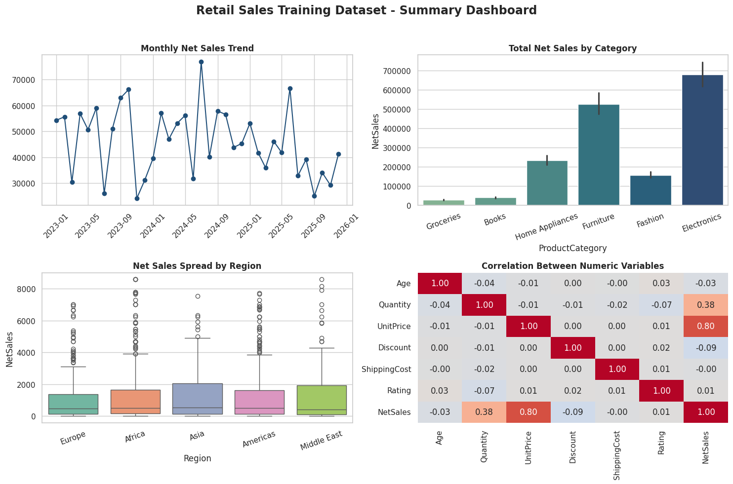

Course Summary
Data cleaning covered: missing values (dropna, fillna, forward/backward fill,
interpolation), duplicate removal (exact and key-based), data type conversion (astype,
pd.to_numeric, pd.to_datetime), text cleaning (str.strip, str.lower/upper/title,
str.replace, str.contains, str.extract, str.split), categorical standardisation with
mapping dictionaries and np.where, outlier handling (IQR method, domain-rule cleaning,
clip), and column renaming and reordering.
Data manipulation covered: selection and filtering (loc, iloc, boolean indexing,
isin, between, query), sorting (sort_values, nlargest, nsmallest), new columns
(vectorised arithmetic, apply, lambda, np.select), groupby and aggregation (including
named aggregation), pivot_table and crosstab, reshaping (melt, pivot, stack,
unstack), merging and concatenation (merge with every join type, concat), binning
(cut, qcut), ranking and cumulative statistics (rank, cumsum, diff, pct_change),
time series tools (resample, rolling, the .dt accessor), MultiIndex operations, and
apply / map.
Matplotlib charts covered: line, vertical bar, horizontal bar, stacked bar, grouped bar,
histogram, box plot, scatter and bubble chart, pie chart, area chart, stacked area chart,
step plot, stem plot, error bar plot, dual axis chart, multi-panel subplots, and saving a
figure to file.
Seaborn charts covered: scatter plot, line plot, bar plot, count plot, box plot, violin
plot, strip plot, swarm plot, histogram with KDE, KDE plot, ECDF plot, correlation heatmap,
pivot-table heatmap, regression plot (regplot and lmplot), pair plot, joint plot, cat
plot, point plot, facet grid, and theme / palette / context styling.
---
Prepared by: Kajola Gbenga
Data Scientist & AI Engineer

End of Training Manual
This manual covered the full pandas data cleaning and manipulation toolkit, every major Matplotlib chart type, and every major Seaborn chart type, all demonstrated on one realistic, deliberately messy retail sales dataset. Use it alongside the notebook and the Excel and CSV data files for a complete, hands-on training session.
Prepared by: Kajola Gbenga
Data Scientist & AI Engineer

